

**Software Requirements Specification**

**Topic: Car Market**

**Subject: Application development project**

**(SWP391)**

**Class:** SE1872-NJ

**Group:** 3

**Member:**

NGUYỄN DUY TUẤN – HE171613 (Team leader)

**Teacher:**

**Ha Noi - 2024**

**Thank You**

**Before coming to this SRS version. I would like to send my most sincere thanks to the teachers of the exam board for SWP391 today. I would like to thank the teachers for putting in the effort to listen to our final report on this subject. Thank you, teachers, for taking the time to read these extremely immature reports and acknowledge my efforts. Even though I was not taught by teachers, today I am very honored to be graded by teachers. I hope that my teachers will grade my papers according to my actual ability, helping me realize my mistakes during the project process. Most of all, I want to be recognized for the effort I put in not only for this subject but also for the experiences of the long road ahead.**

**No matter what the outcome is, I still accept it wholeheartedly.**

**Once again, I would like to sincerely thank my teachers!**

**Tuấn**

**Nguyễn Duy Tuấn**

**Table of Contents**

**Table of Contents ii**

**Revision History ii**

**1.** **Introduction 2**

1.1 Purpose 2

1.2 Document Conventions 2

1.3 Project Scope 2

1.4 References 2

**2.** **Overall Description 2**

2.1 Product Perspective 2

2.2 User Classes and Characteristics 2

2.3 Operating Environment 2

2.4 Design and Implementation Constraints 2

2.5 Assumptions and Dependencies 2

**3.** **System Features 2**

3.1 System Feature 1 2

3.2 System Feature 2 (and so on) 2

**4.** **Data Requirements 2**

4.1 Logical Data Model 2

4.2 Data Dictionary 2

4.3 Reports 2

4.4 Data Acquisition, Integrity, Retention, and Disposal 2

**5.** **External Interface Requirements 2**

5.1 User Interfaces 2

5.2 Software Interfaces 2

5.3 Hardware Interfaces 2

5.4 Communications Interfaces 2

**6.** **Quality Attributes 2**

6.1 Usability 2

6.2 Performance 2

6.3 Security 2

6.4 Safety 2

6.5 [Others as relevant] 2

**7.** **Internationalization and Localization Requirements 2**

**8.** **Other Requirements 2**

**Appendix A: Glossary 2**

**Appendix B: Analysis Models 2**

**Revision History**

|  |  |  |  |
| --- | --- | --- | --- |
| **Name** | **Date** | **Reason For Changes** | **Version** |
| Nguyễn Duy Tuấn | 28/7/2024 | complete | 1.0 |
|  |  |  |  |

**1.Introduction**

**Introduction to Our Car Sales Platform**

Welcome to Car Market, the ultimate online marketplace for car enthusiasts and businesses alike. Inspired by leading platforms like bonbanh.com, our website offers a comprehensive solution for both buyers and sellers of automobiles. Whether you're a business looking to showcase your car sales packages or an individual interested in exploring a vast array of vehicles, we've got you covered.

### Key Features

* **Post Promotions and Advertisements**: Businesses can easily create and manage promotional content to reach potential buyers. Highlight special offers, new arrivals, and exclusive deals to capture the attention of your audience.
* **View Car Listings**: Customers can explore a wide variety of car listings posted by owners. From luxury sedans to compact cars, our platform provides detailed information to help you make informed decisions.
* **Advanced Car Search**: Our powerful search tool allows customers to find specific car models, brands, and features quickly and efficiently. Filter through our extensive database to locate the perfect vehicle that meets your needs..

Join us a Car Market and experience the future of car buying and selling. Our platform is designed to make the process easy, secure, and enjoyable for everyone involved. Whether you're buying your first car or expanding your dealership, we're here to support your journey every step of the way.

# 2. Overall Description

## Product Perspective

This is an upgrade based on a product already available on the market. However, members of my group dropped out of this subject, the product could not be completed, so I could only complete a few functions according to my own work.

## User Classes and Characteristics

This system support for the below types of user:

• **Client**: Customer who only can view the post and posting

• **Admin** are users of the system's services. Admin can use some of the following functions:

- Login

- View the home page:

+ List Post By brand

+ List Post By Model

+ Create other account

+ Delete other account

+ Update active account

- Search

- List newest post

- List all post

- List Account

- Insert Model

- Insert Brand

- View Detail Post

- View Post Owner Information

- View Model

- View Brand

View Feedback

• **Staff** is people who works directly with system to track the information of customer or manages customer, staff can handle directly some problems if it happens from customer. Staff can use some following functions:

- view Home Page

- View Provider home

- List Post By Brand

- List Post By Model

- List Account

- Search

- List newest Post

- List All Post

-List All Post For Provider

- Post Approval

- View Detail Post For Provider

- View Detail Post

- View Post Owner Information

- View Model

- View Brand

- View Feedback

• **Manager**

- Home page

- Provider home

- List Post By Brand

- Insert Brand

- List Post By Model

- Insert Model

- List Account

- Insert Brand

- View Detail Post

- View Post Owner Information

- View Model

-View Brand

- View Feedback

## Operating Environment

* + 1. **Configuration**
* Minimum configuration

RAM: 2 GB

Graphics card: Intel HD

CPU: Intel core i3-4th Gen

Memory: 15 GB

* Recommended configuration

RAM: 8GB

Graphics card: Intel UHD

CPU: Intel core i5-8th Gen

Memory: 30 GB

* + 1. **Recommended browser**

The program can run on browsers such as Microsoft Edge, Google Chrome, Coc Coc,...

Google Chrome is the recommended browser

Instructions for installing Google Chrome:

**Step 1:** Visit the following website: https://www.google.com/chrome/

In the new window that appears, click "Download Chrome"

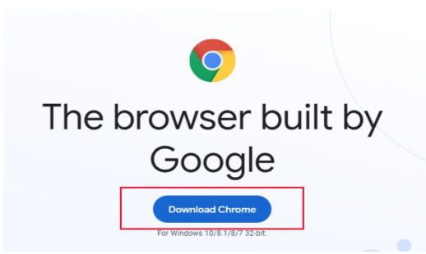

**Step 2**: Double click on the downloaded ChromeSetup.exe file

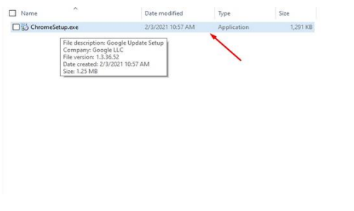

**Step 3:** The Open File - Security Warning window appears, click Run

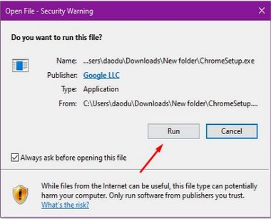

**Step 4**: If the UAC window appears, click Yes. Chrome will download the packages

installation and automatic installation

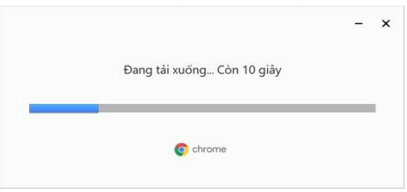

**Step 5:** Once done, Chrome will automatically open as shown below.

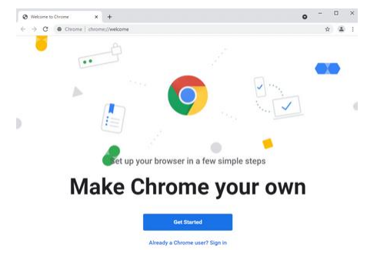

* + 1. **Software required**

**a, Installing JDK 17**

<https://www.oracle.com/java/technologies/downloads/>

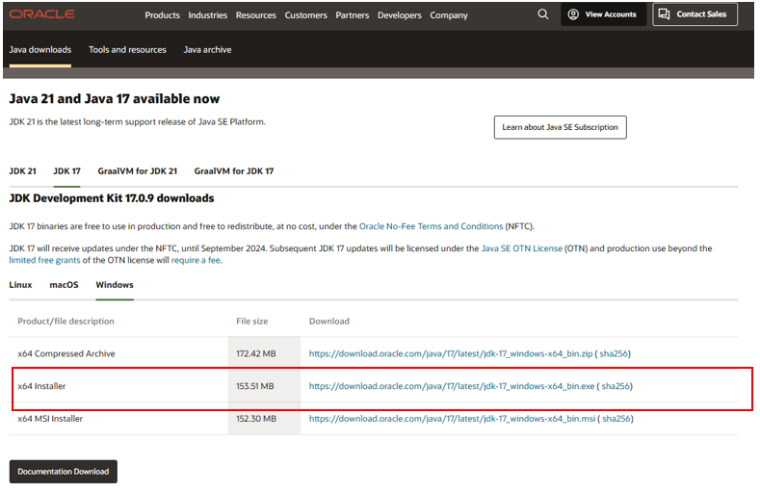

After installing, let check the installation folder:

Normally it will be located at: C:\Program Files\Java. It contains 1 folder JDK-17.

If you see these folders, it is ok for now.

For more details, you can read <https://www.oracle.com/java/technologies/javase-jdk8-doc-downloads.html>

**b,**  **Installing Apache Tomcat 10.1.x**

Link: https://tomcat.apache.org/download-10.cgi

Open the installer file then click “Next” button, until you see the below screen:

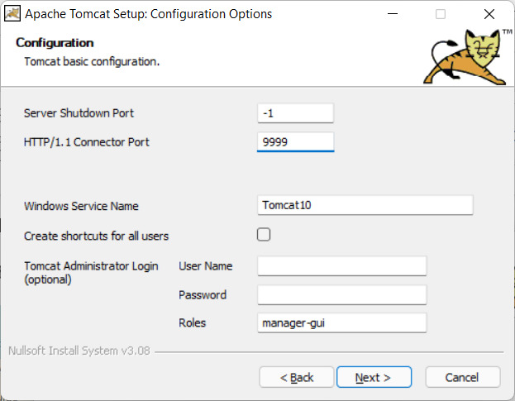

By default, the HTTP port is set as 8080, but I prefer to change it to 9999. You can keep it as 8080 or change it as you desire. Same for Window Service Name.

You can also set username and password at this step, but it is an optional and you can do it later.

Click “Next”, then the installer will ask you for JDK-17 folder. Basically, the installer can automatically detect JDK-17 folder, but in the case it cannot, you can add it manually.

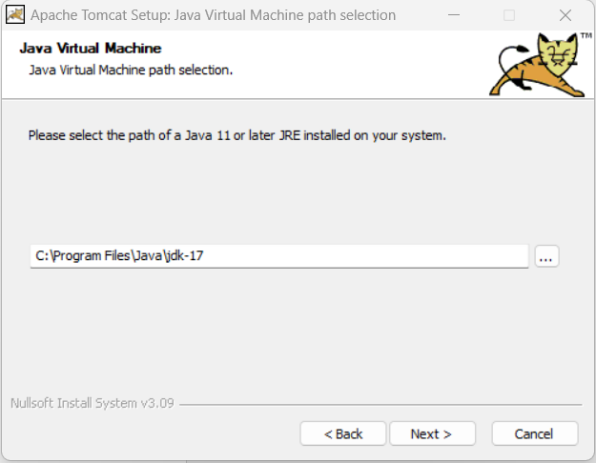

Click “Next” …. Again then “Finish”.

Normally, you are going to see the below window app displayed:

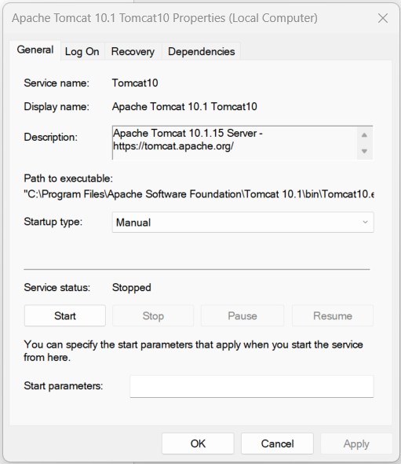

It is ok, this application used to control your TOMCAT webserver, but if you do not see it, do not worry. I recommend you follow below instructions:

1. TOMCAT now is installed as a Window Service (It is a software, but it does not have a graphic user interface).
2. To work with Window Service, press window+R, fill service.msc

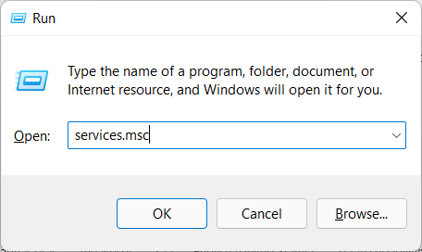

1. Find the TOMCAT service in the list:

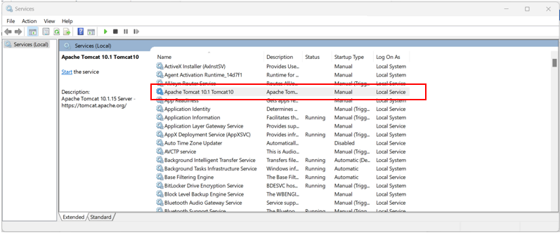

Right click -> properties ->



Now you can start/stop the TOMCAT service. Just make sure it is running before use.

You can grant permission for TOMCAT to run with Local System account on the same dialog.

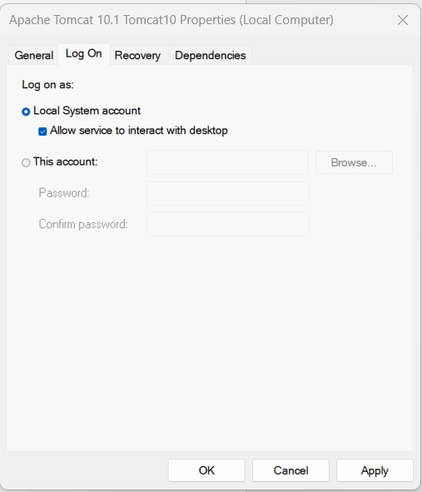

**c, Installing Apache NetBeans IDE 17**

Download: https://netbeans.apache.org/front/main/download/nb17/

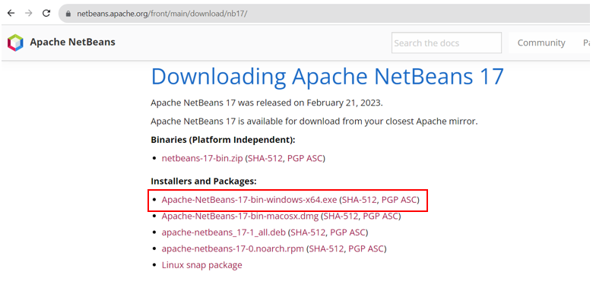

During your installation, remember to select JDK 17 (just in case, you have more than one version of Java).

After installation, run Netbeans 17, File > New Project > Java with Ant > Select Web Application (It is disabled by default, just select it, netbeans will automatically enable the project template).

**d, Integrating Apache NetBeans IDE 17 with Apache Tomcat.**

+ First, open the Apache Tomcat folder:

By default, it is located at: C:\Program Files\Apache Software Foundation\Tomcat 10.1

The system may ask you to grant permission, just click “Yes” button. This step aims to allows your account to access the Apache Tomcat folder for further tasks.

**+** Open Netbeans, on the menu bar, Window > Service (ctrl + 5) > select Service panel as following:

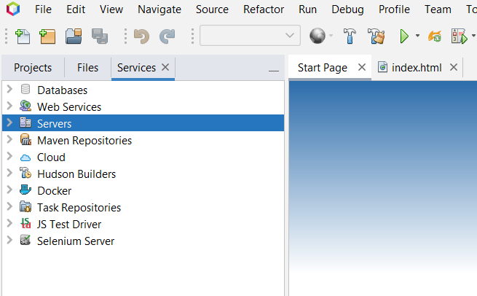

Server > Right click > Add Server > Apache Tomcat and TomEE >

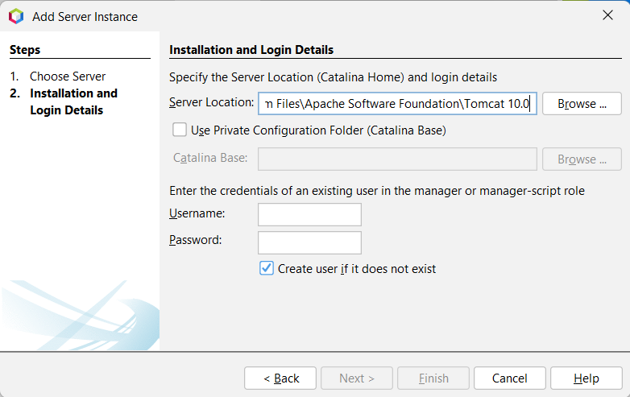

Here you can create your username and password, then finish. Now you can work with Java Web project in netbeans 17.

If you get an error related to “CATALINA_base is Invalid”, check the first step.

Errors related to Tomcat will be logged to “C:\Program Files\Apache Software Foundation\Tomcat 10.1\logs”, check the catalina**** file for the detail logs.

**e, Create Java Web project, Servlet and Debug.**

To create a new java web project: File > New Project > Java with Ant> Java Web > Web Application (See the below figure)

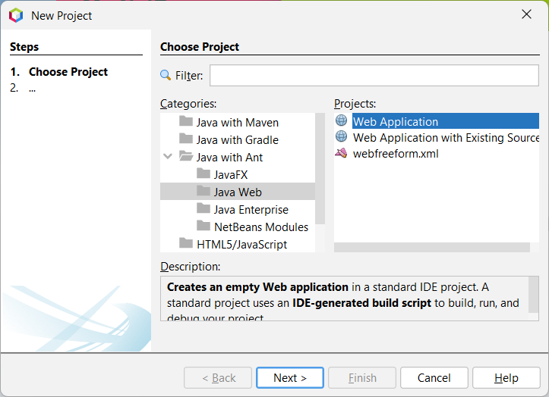

/// LET DO IT, IN THE SESSION OF SERVLET

Once you create new Servlet via Netbeans template file. By default, netbeans using javax, which is not included in Jarkata EE platform equipped by Tomcat 10. Just need to replace all javax by Jakarta package, then everything will be compiled.

|  |  |
| --- | --- |
|  |  |

Refer to <https://tomcat.apache.org/> for more detail

you can also edit the template file for further tasks.

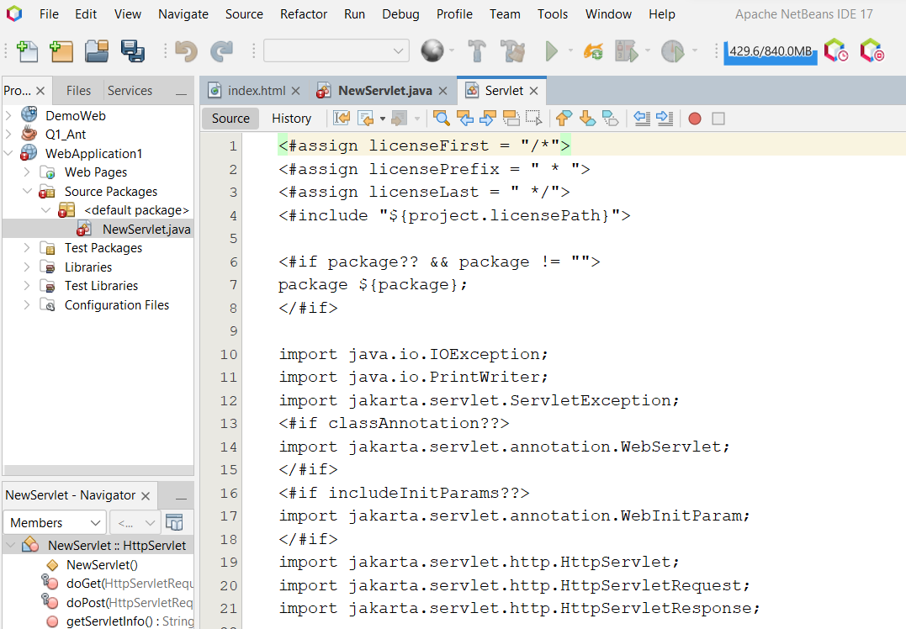

**//** For one who cannot start debugging mode with apache tomcat 10. Open task manager window then kill the process of Java SE.

Check the video: <https://youtu.be/9Zcy7yWNAm4>

OR

Open window PowerShell, type command:

get-process

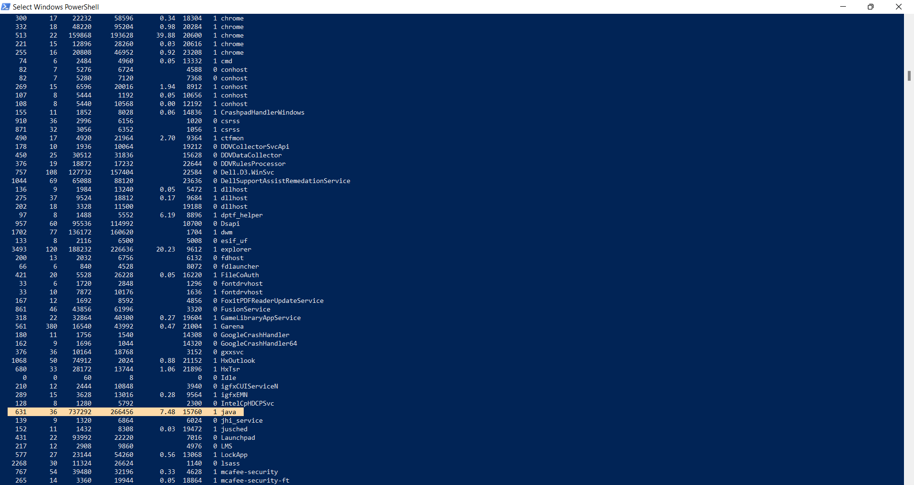

Find java-se process id, then type command:

taskkill /pid 15760 /F

Now you can try debugging again with NetBeans and tomcat.

f, **Working with JSTL.**

Latest version of JSTL build on J2EE was 1.2x. Since the Tomcat 10 is using Jakartified version (with jakarta.* package instead of javax.* package), use JSTL 2.0 to solve this dependency:

Download: Jakarta Standard Tag Library API

Link: <https://search.maven.org/artifact/jakarta.servlet.jsp.jstl/jakarta.servlet.jsp.jstl-api/2.0.0/jar>

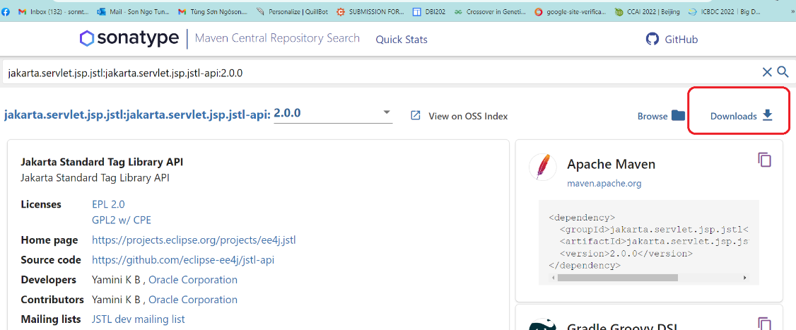

Download: Jakarta Standard Tag Library Implementation

Link: <https://search.maven.org/artifact/org.glassfish.web/jakarta.servlet.jsp.jstl/2.0.0/jar>

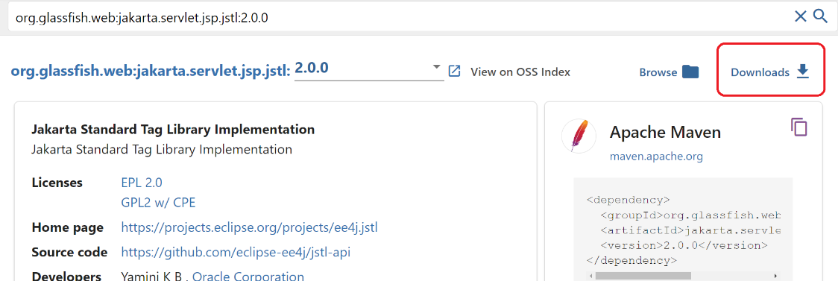

Check the document here:

<https://jakarta.ee/specifications/tags/2.0/jakarta-tags-spec-2.0.html>

**g, Install Microsoft SQL Server**

## Download and Install Microsoft SQL Server 2022

You can download the installation file from Microsoft.com: [SQL Server 2022 Download](https://www.microsoft.com/en-us/sql-server/sql-server-downloads)

You have several options:

* **SQL Server on Azure** - is the version in the Microsoft cloud. For more information, refer to [this link.](https://www.mssqltips.com/sqlservertip/7438/azure-sql-database-overview/)
* **SQL Server at the edge** - is a SQL Server for the IoT (Internet of Things). This is used to get real-time data with high-performance for IoT solutions.
* **SQL Server on-premises** - is for SQL Server installed on local machines.

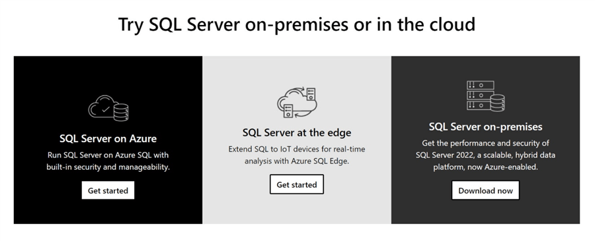

In addition, there are 2 free versions.

* **Developer** - which has all the features of the SQL Server Enterprise edition.
* **Express** - which is also free, but has limited features.

The main differences between the Developer and the Express edition is that you can use the Express edition in production (but it has several feature limitations) whereas the Developer edition can be used only in Development, Testing or for Teaching purposes.

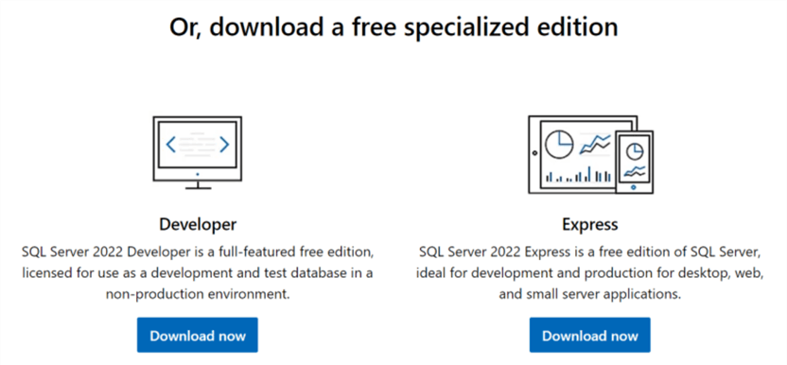

Finally, you have 3 options:

* **Windows** - to install in your local server in a Windows machine or Virtual Machine with Microsoft Windows.
* **Linux** - to install SQL Server on Linux. For more information about Linux, refer to this article.
* **Docker** - is like a simplified virtual machine that contains the necessary components to run an application without requiring an entire operative system. It is a very portable lightweight container to run applications.

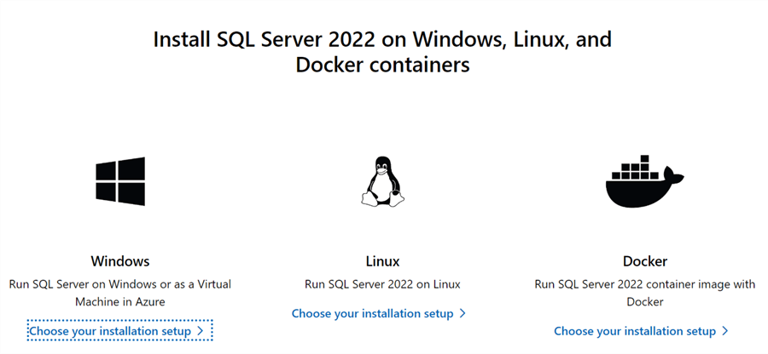

In this example, we will install SQL Server Developer edition on-premises.

Download the installer and once downloaded the installation wizard has 3 options:

* **Basic** - install SQL Server with the default options.
* **Custom** - this option allows you to select the components to install. You will be able to select several other options like SSIS, SSAS, DQS, MDS and other features.
* **Download Media** - this option allows you to download the installer and run the install later.

For this article, we will use **Custom**.

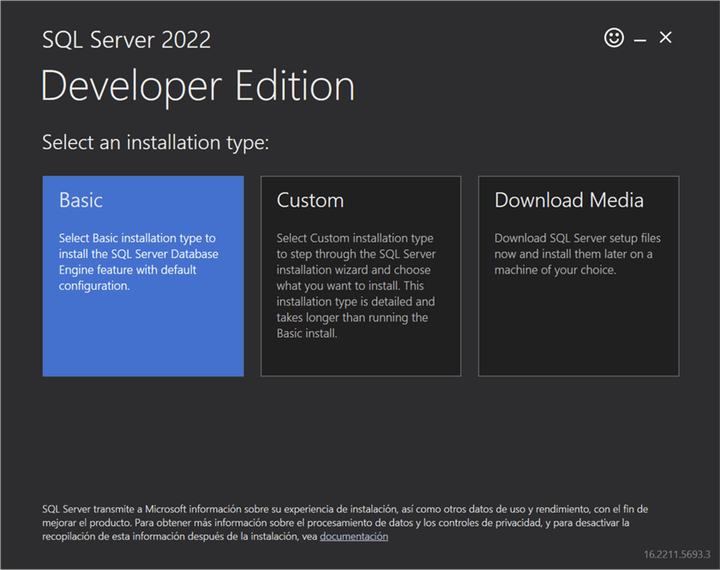

Next, the installer will ask where to save the download, once selected press **Install**.

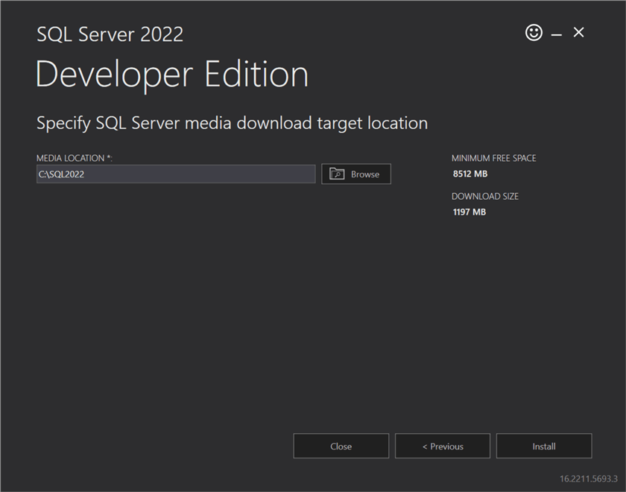

This will download and run the install package.

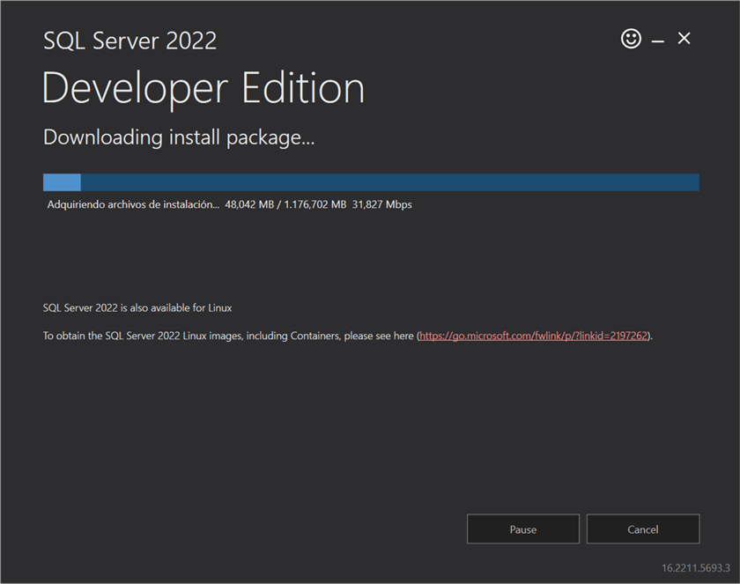

The **SQL Server Installation Center** will open after the download completes and on the **Installation** page, we have the following options. We will select **Installation** to install SQL Server.

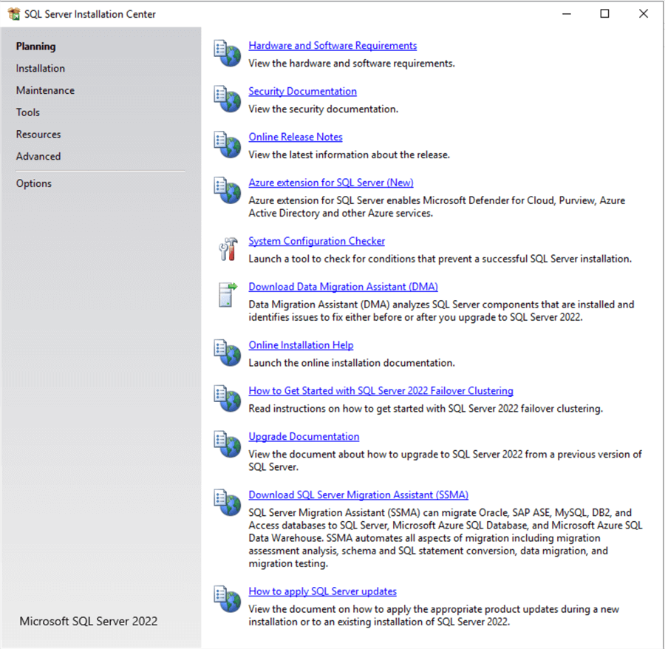

On the installation page we have the following options.

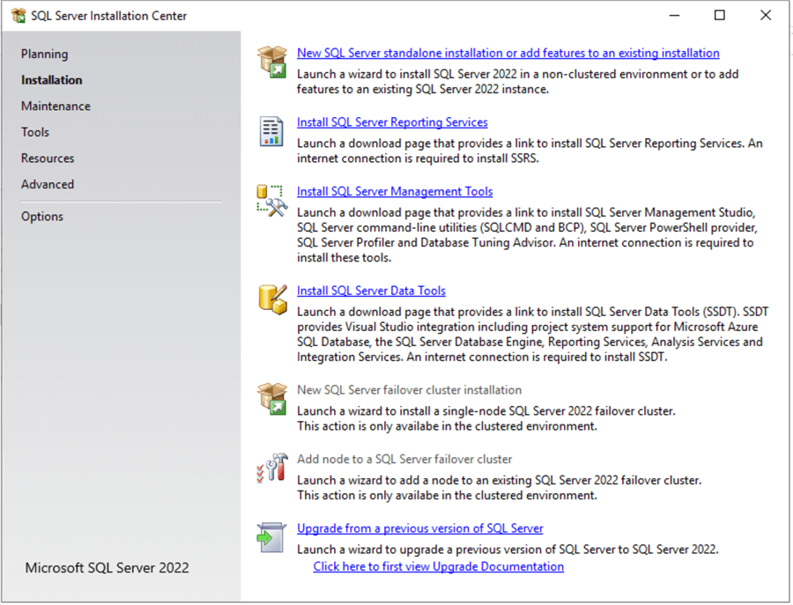

1. New SQL Server stand-alone installation or add features to an existing installation.
   * We will use this option to install a new instance.
2. [Install SQL Server Reporting Services.](https://www.mssqltips.com/sqlservertutorial/9079/sql-server-reporting-services-ssrs-2017-installation-and-configuration-setup/)
   * This software is used to create Reports not only from SQL data, but also from other data sources.
3. Install SQL Server Management Tools
   * Install various tools to work with SQL Server.
4. Install SQL Server Data Tools
   * In the past, you could install Analysis Services, SSRS, and SSIS projects with SSDT, but starting with [Visual Studio 2019, these projects are not included with SSDT](https://www.mssqltips.com/sqlservertip/6481/install-sql-server-integration-services-in-visual-studio-2019/).
5. [New SQL Server failover cluster installation](https://www.mssqltips.com/search/?q=clustering-sql-server-2019-step-by-step)
   * Install a new node in a failover cluster used for high availability
6. Add node to a SQL Server failover cluster
   * Add nodes to a failover cluster
7. Upgrade from a previous version of SQL Server
   * Let’s you upgrade from a previous SQL Server version

We will pick **New SQL Server stand-alone installation or add features to an existing installation**.

There will be a few screens to go through to check for any updates

#### Edition

On the next screen, you can enter a product key or use a free edition. You can use 3 options:

* **Evaluation**. The evaluation edition is for 180 days duration.
* **Developer**. The Developer edition is for development purposes, testing or teaching purposes. It cannot be used in Production.
* **Express**. This version can be used in production, but it comes with various feature limitations.

In addition, you can use the pay-as-you-go billing through Microsoft Azure option. This option is great if you want SQL Server for a limited time or if you do not use on weekends. You can scale out or scale down. This option offers an Enterprise and Standard edition. The main differences between these 2 options are the features available. The enterprise edition contains all the features, whereas the Standard edition has some limitations.

Also, you can use the product key. The product key is used to specify the license of your SQL Server. If you purchase a license. Microsoft will provide you license for an Edition of SQL Server. You will need to enter an alphanumeric key in SQL Server.

There are 2 options for the product key.

* I have a SQL Server license with Software Assurance or SQL Subscription. If you have a subscription or a software assurance, your payment will be reduced. The software assurance also includes some benefits during the upgrades, migration and technical support.
* I have a SQL Server license only. This option means that you will enter the license only and you do not have a Software Assurance or a SQL Server Subscription.

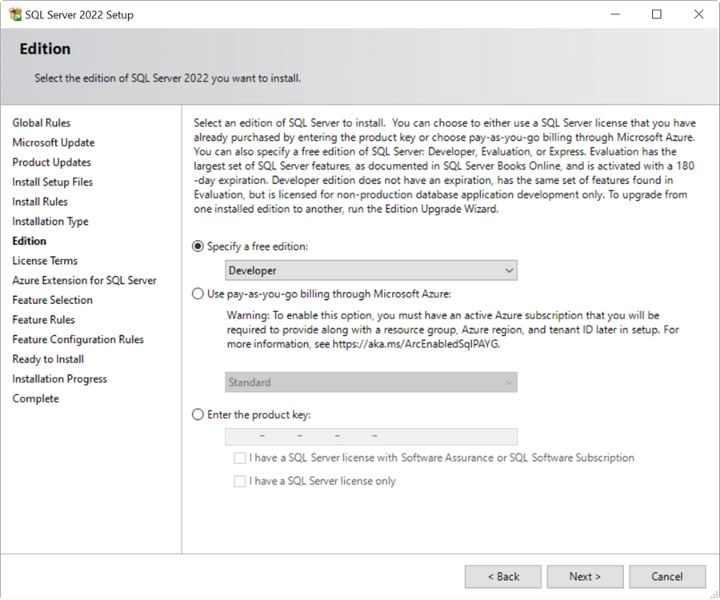

##### License Terms

Read the license terms to make sure that you agree and press **Next** .

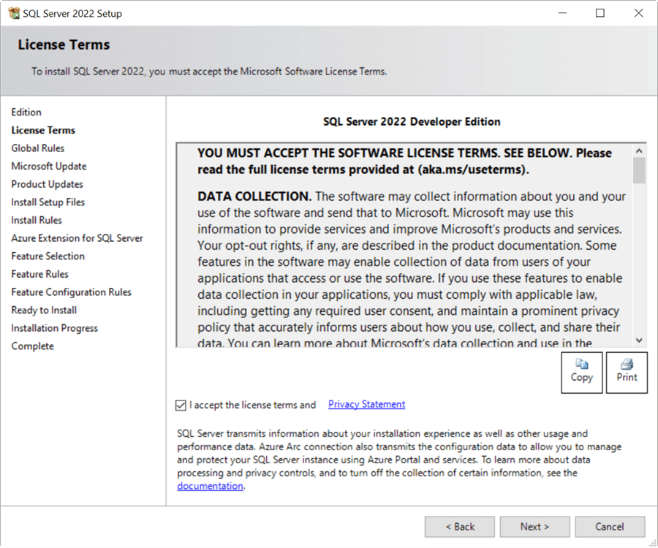

##### Microsoft Update

The Microsoft Update can check if there are updates. You can enable this option and Microsoft Update will check for updates. Press **Next** to continue.

In Microsoft SQL Server, the updates are using the CUs. The CUs are Cumulative Updates. These updates contain patches and fixes to improve the functionality and security of the SQL Server. Make sure to have your CUs updated.

You can see the last CU for SQL Server 2022 [here](https://www.microsoft.com/en-US/download/details.aspx?id=105013).

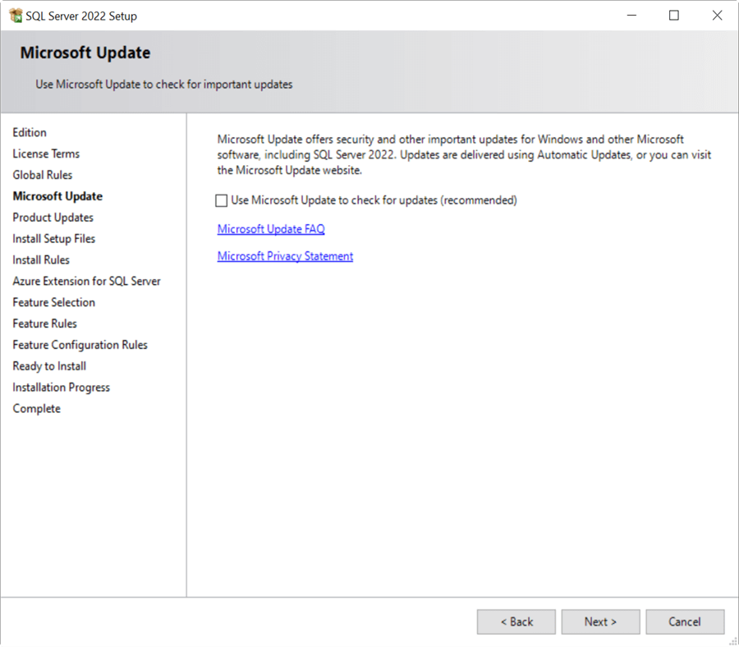

#### Install Rules

The install rules window verifies possible problems during the installation. For example, the machine may not have the current .NET framework installed, or the firewall may need some ports enabled. In this example, we have two warnings. The firewall and the side-by-side upgrade warnings. You can click view detailed report for more details or on the warning link to get more info. Note, it is not recommended to install the machine on a domain controller and the .NET framework that is recommended is 4.7.2 or later.

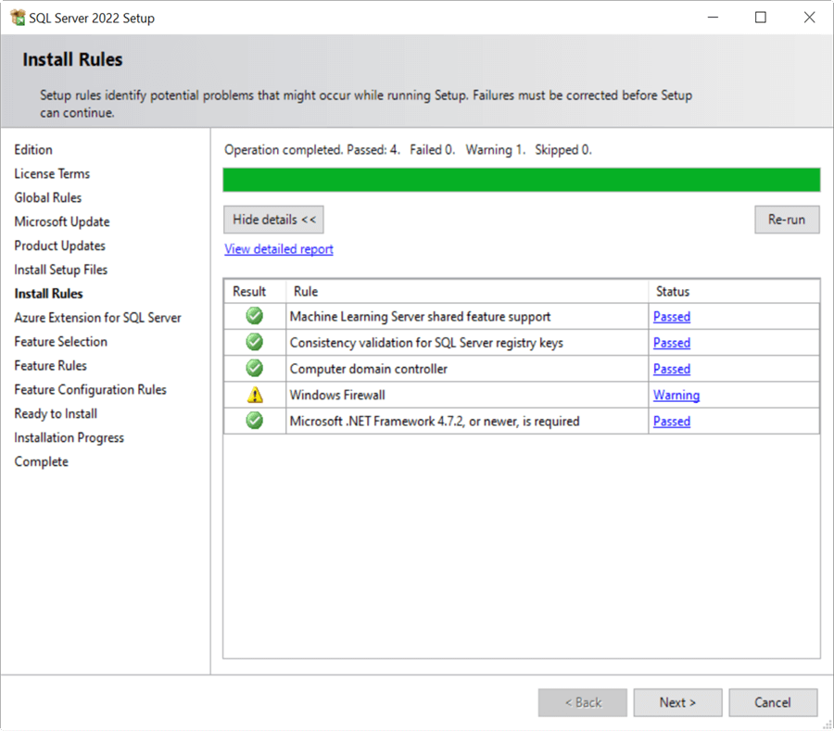

##### Windows Firewall Warning

If the firewall is enabled, you need to check if the required ports are enabled. If they are disabled, your services may not work. If you need more information about SQL Ports, please refer to this link: [SQL Server Ports for Various Components](https://www.mssqltips.com/sqlservertip/7212/sql-server-port-explanation-usage/). If you need more information to configure the firewall, please refer to this link: [Configure Windows Firewall to Work with SQL Server](https://www.mssqltips.com/sqlservertip/1929/configure-windows-firewall-to-work-with-sql-server/).

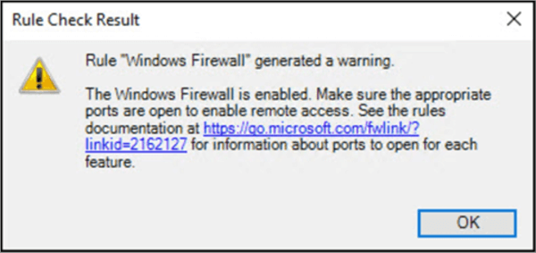

#### Azure Extension for SQL Server

You can enable the Azure Extension for SQL Server. This new feature allows to register your SQL Server and use the Azure AD, the Azure Arc-enabled SQL Server using a pay-as-you-go billing. You will need to have an Azure Account for this feature. If you want to install it later, you can configure using the Azure Portal or using the Azure API.

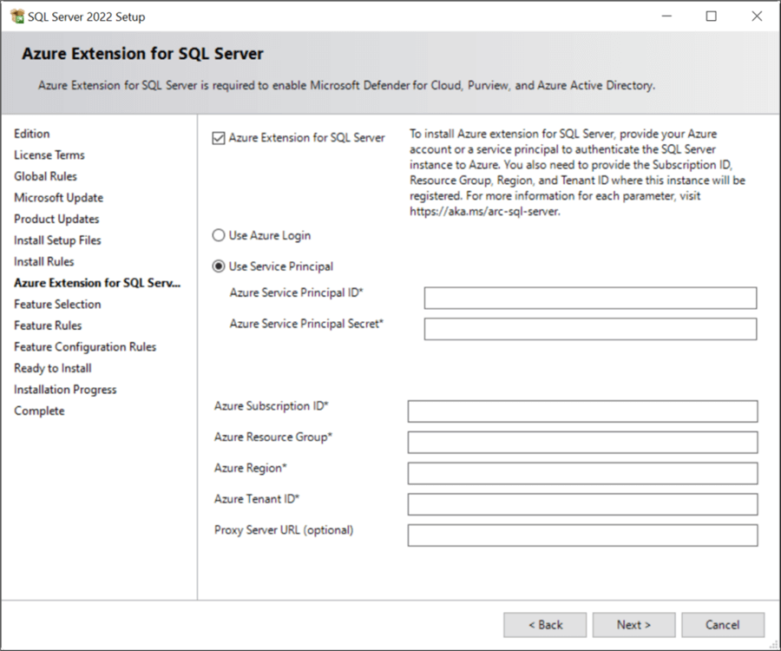

#### Feature Selection

The feature selection includes several options as shown below.

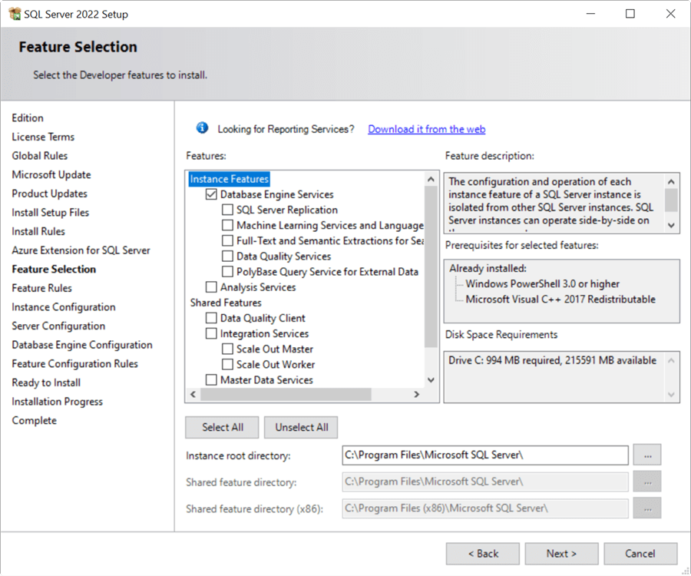

* Database Engine Services
  + Main component of SQL Server
* SQL Server Replication
  + Replicate data to different databases or SQL Servers. For more information, please refer to this [replication article](https://www.mssqltips.com/sqlservertip/6129/sql-server-replication-overview/).
* [Machine Learning Services](https://www.mssqltips.com/sqlservertutorial/9042/machine-learning-services-installation-and-configuration/) and Languages Extension
  + Run [R](https://www.mssqltips.com/sqlservertutorial/9040/getting-started-with-r-in-sql-server/) and [Python](https://www.mssqltips.com/sqlservertip/5938/introduction-to-sql-server-machine-learning-services-with-python/) in your SQL Server database
* [Full Text and Semantics](https://www.mssqltips.com/sqlservertip/6840/sql-server-full-text-search/)
  + Search large sets of text in the database. This is a powerful search service that can improve performance when searching text data.
* [Data Quality Services](https://www.mssqltips.com/sqlservertip/2575/getting-started-with-sql-server-2012-data-quality-services-part-1/)
  + Fix, enrich, standardize and check your data.
* [PolyBase](https://www.mssqltips.com/sqlservertip/4080/introduction-to-polybase-in-sql-server-2016-part-1/) Query Service
  + Integrate Big Data Hadoop solutions with SQL Server
* [Analysis Services](https://www.mssqltips.com/sqlservertutorial/2000/sql-server-analysis-services-ssas-tutorial/)
  + Service for SQL Server OLAP solutions
* Data Quality Client
  + Manage and handle data quality
* [Integration Services](https://www.mssqltips.com/sqlservertip/6787/what-is-ssis/)
  + Import and export data with custom workflows. You can use the [Scale Out Master](https://www.mssqltips.com/sqlservertip/4879/sql-server-vnext-sql-server-2017-ssis-scale-out-feature/) or the Scale Out Worker. These configurations are related to the package execution work process and optimize the execution.
* SQL Client Connectivity SDK
  + Additional tools for connectivity to SQL Server
* [Master Data Services](https://www.mssqltips.com/sqlservertutorial/3800/sql-server-master-data-services-overview/)
  + Centralize and manage similar data across your databases
* SQL Server Extension for Azure
  + Additional extensions that can be used for Azure

We will just install the database engine.

#### Instance Configuration

In the instance configuration, we enter a name to be used for the SQL Server instance. In this example, I am creating a new database engine with the instance name of **instance2022**. You could use the default as well.

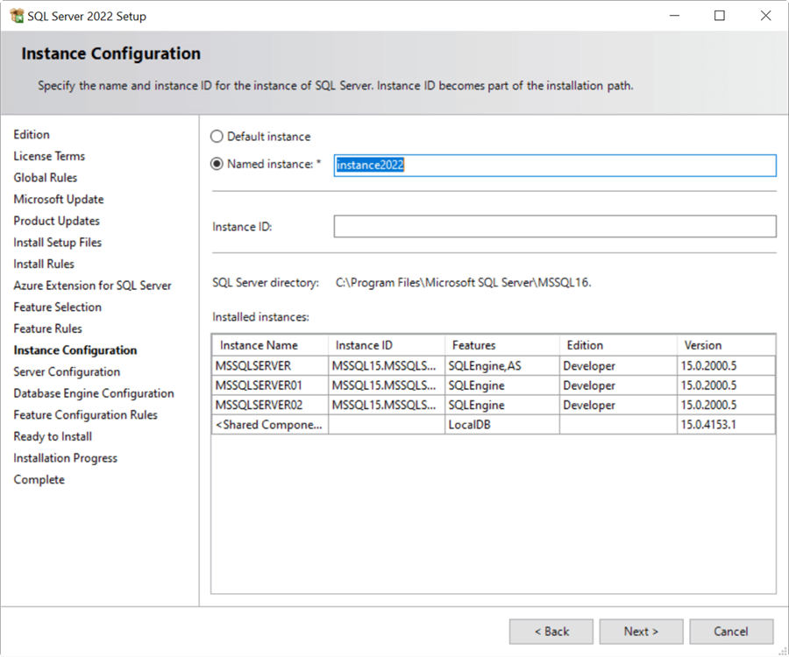

#### Server Configuration

The server configuration allows creating or adding service accounts for the different services used by SQL Server. You can use the defaults or create new accounts with custom security and passwords to run the services.

The Grant Perform Volume Maintenance Tasks privilege to SQL Server Database Engine Service. This privilege improves the performance for database operations like database creation, restorations or improves the speed of the file growth.

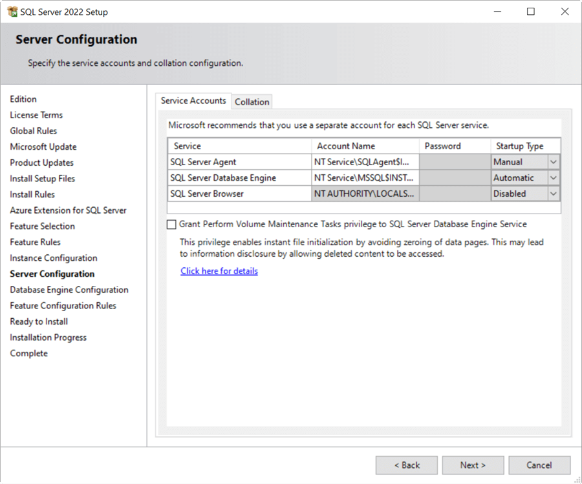

#### Database Engine Configuration

The database engine configuration allows you to configure several parts of the installation.

**Server Configuration**

* Select the type of SQL Server authentication mode to connect the instance, either [mixed mode](https://www.mssqltips.com/sqlservertip/2191/how-to-check-sql-server-authentication-mode-using-t-sql-and-ssms/) or [Windows authentication](https://www.mssqltips.com/sqlservertip/6702/sql-server-windows-authentication-with-users-and-groups/). You can also add accounts that should have complete access to SQL Server. The Add Current User, will add the user used during the installation as an administrator.

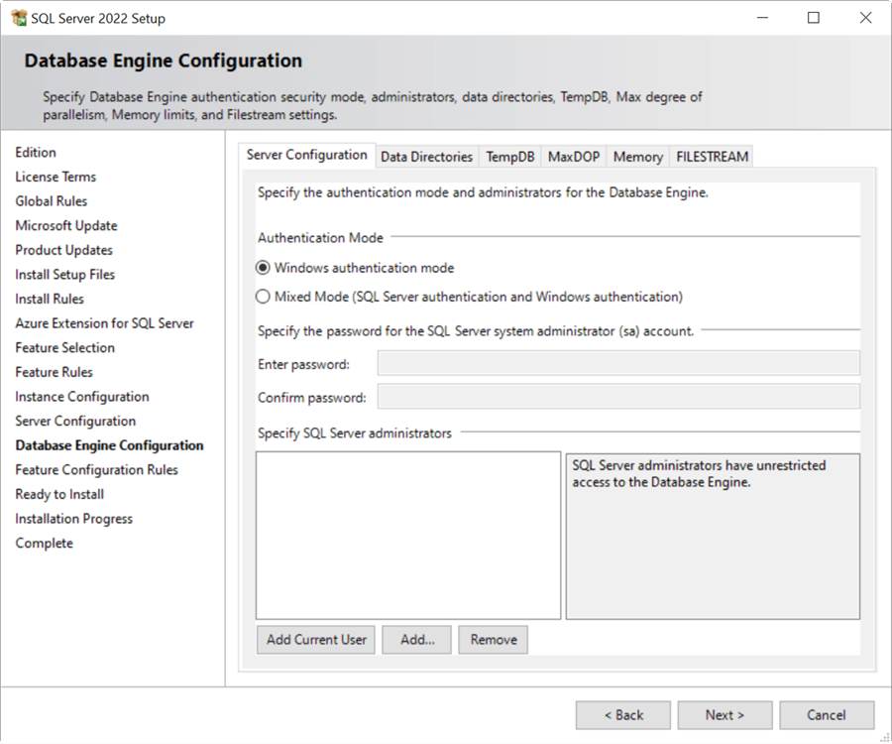

**Data Directories**

You can specify the system database path by configuring your Data root Directory. Also, you can define where to store the Data directory and the Database Log. The backup directory can also be specified. It is a best practice to store the databases, log files and backups in different disks for security and performance best practices.

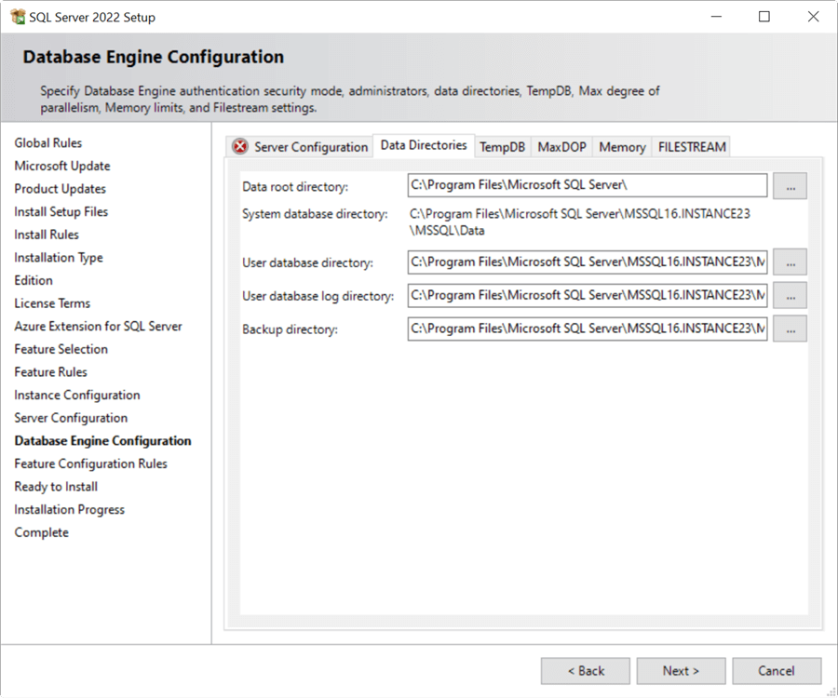

**TempDB**

* The TempDB is an important system database used to store temporary data. The configuration and values specified can improve the performance.

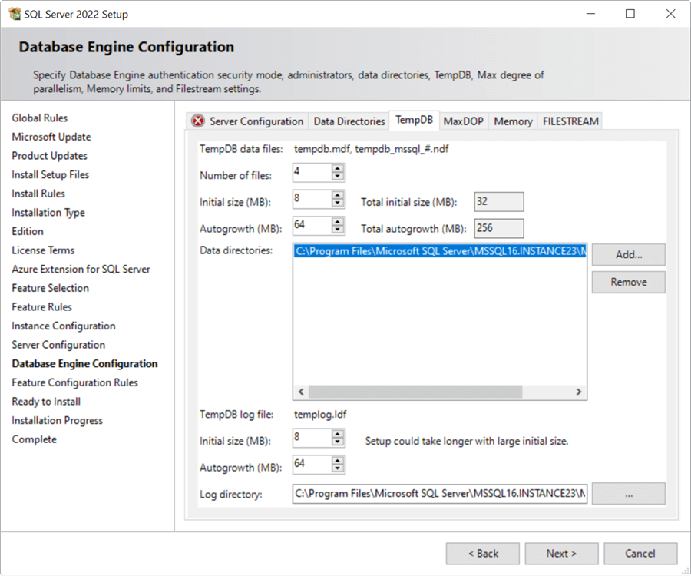

**MaxDOP**

* MaxDOP is important to have a good performance. For more information, please check out this [MAXDOP settings](https://www.mssqltips.com/sqlservertip/2650/what-maxdop-setting-should-be-used-for-sql-server/) article.

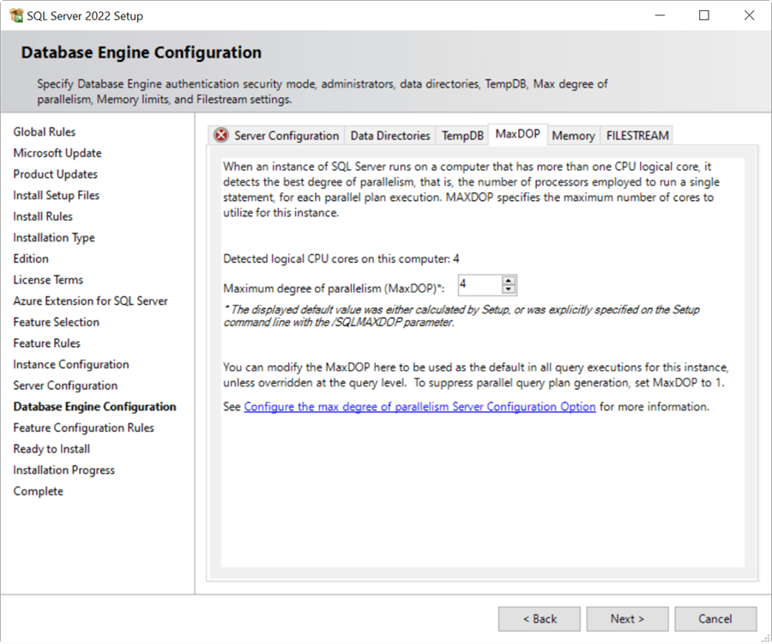

**Memory**

* The memory settings let you specify the maximum server memory used by SQL Server. For more information about setting the max value, please refer to [setting a fixed amount of memory for the SQL Server article](https://www.mssqltips.com/sqlservertip/4182/setting-a-fixed-amount-of-memory-for-sql-server/).

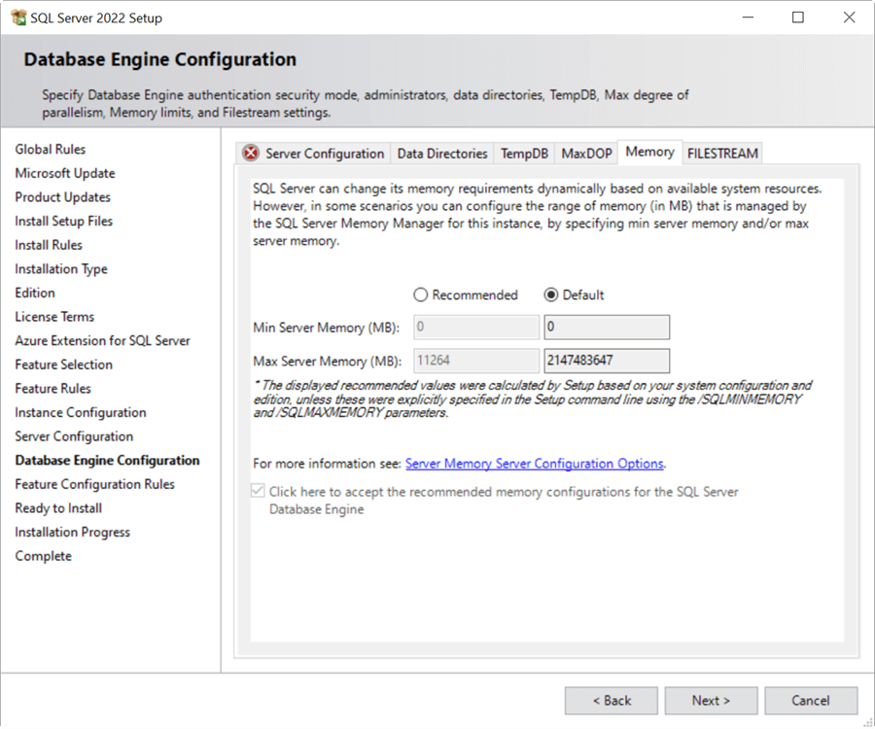

**Filestream**

* [FILESTREAM](https://www.mssqltips.com/sql-server-tip-category/92/filestream/) is used to store files outside of the database like videos, PDFs, Word files, Excel files, and others.

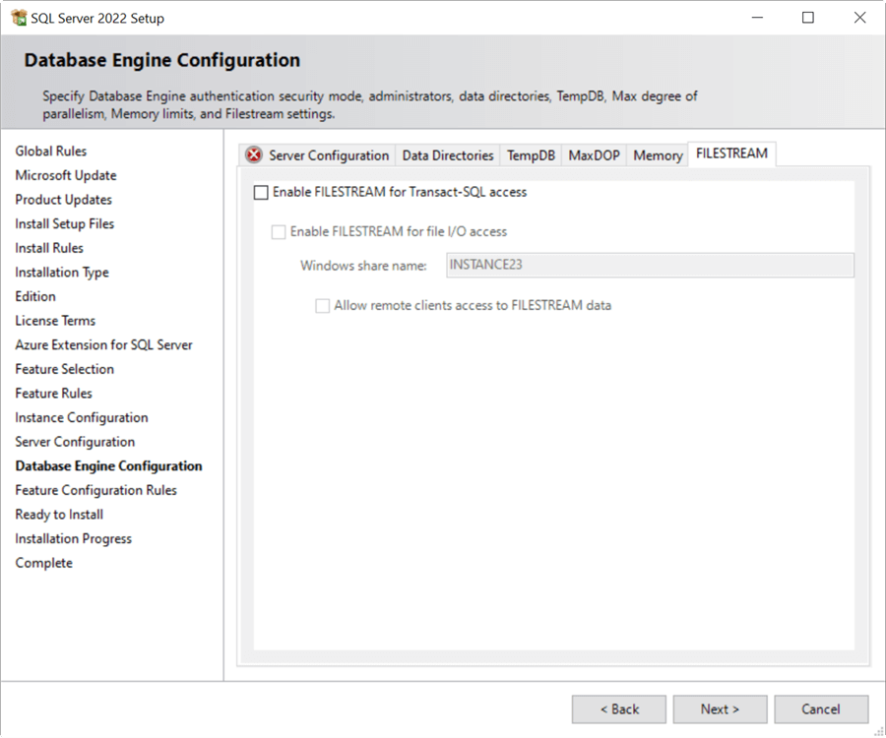

#### Ready to Install

Once everything is configured, you can check the configuration and press the **Install** button to continue. You will now go to the **Installation Progress** windows and finally go to the Complete page.

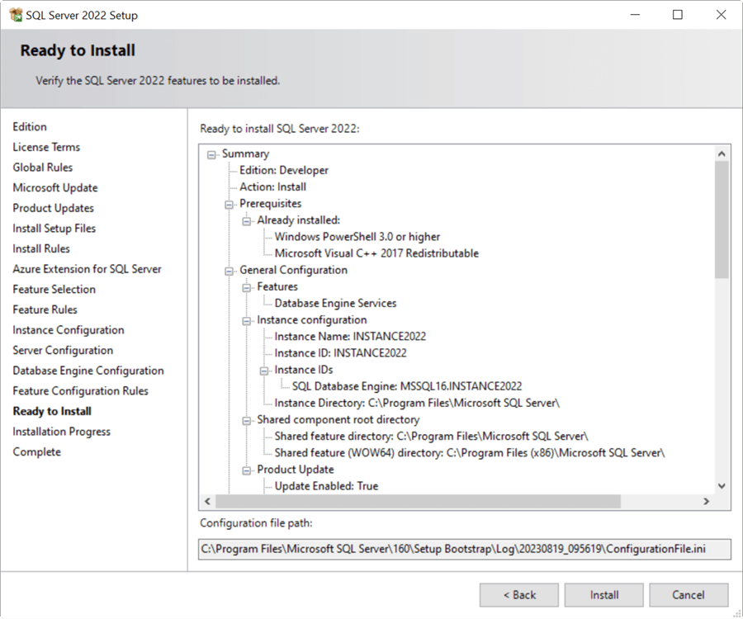

#### Complete

If everything is successful, MS SQL Server 2022 will be installed, and the relational database management system is ready for use.

The installation time takes between 15 and 30 minutes depending on the components installed.

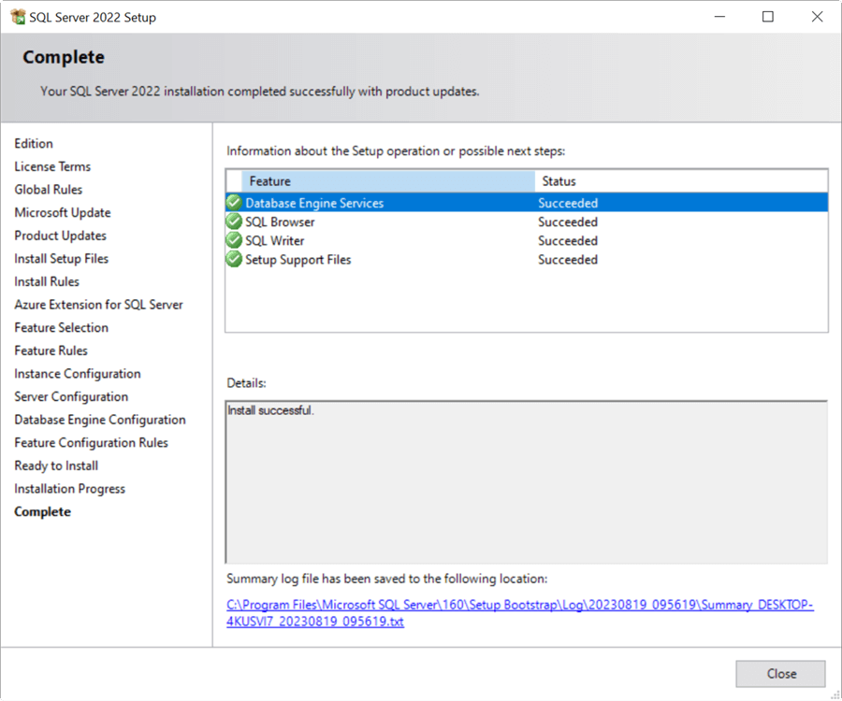

##### Next Steps

The next step is to connect to SQL Server and begin working on SQL database development and administration. To do that, you should download Microsoft SQL Server Management Studio (SSMS).

Check out these resources to get started:

# System Features

Use case diagam here

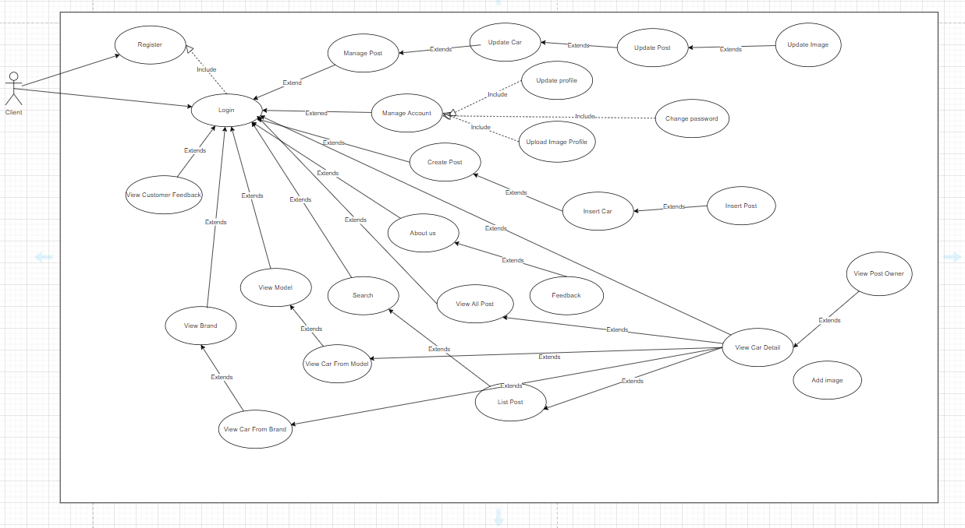

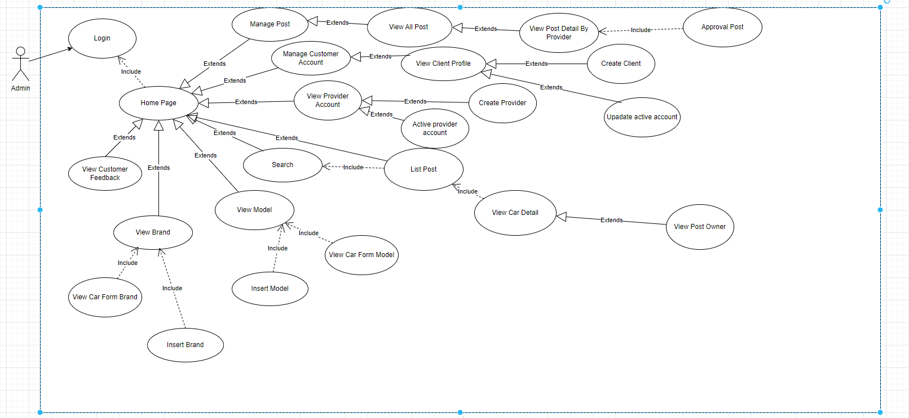

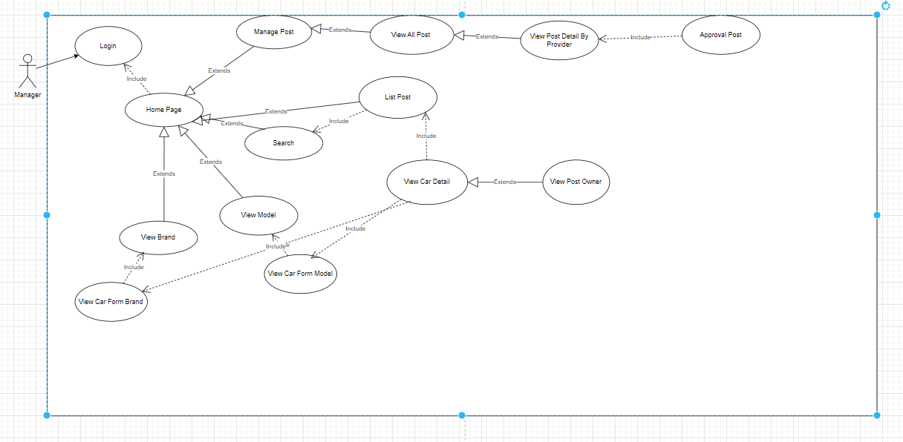

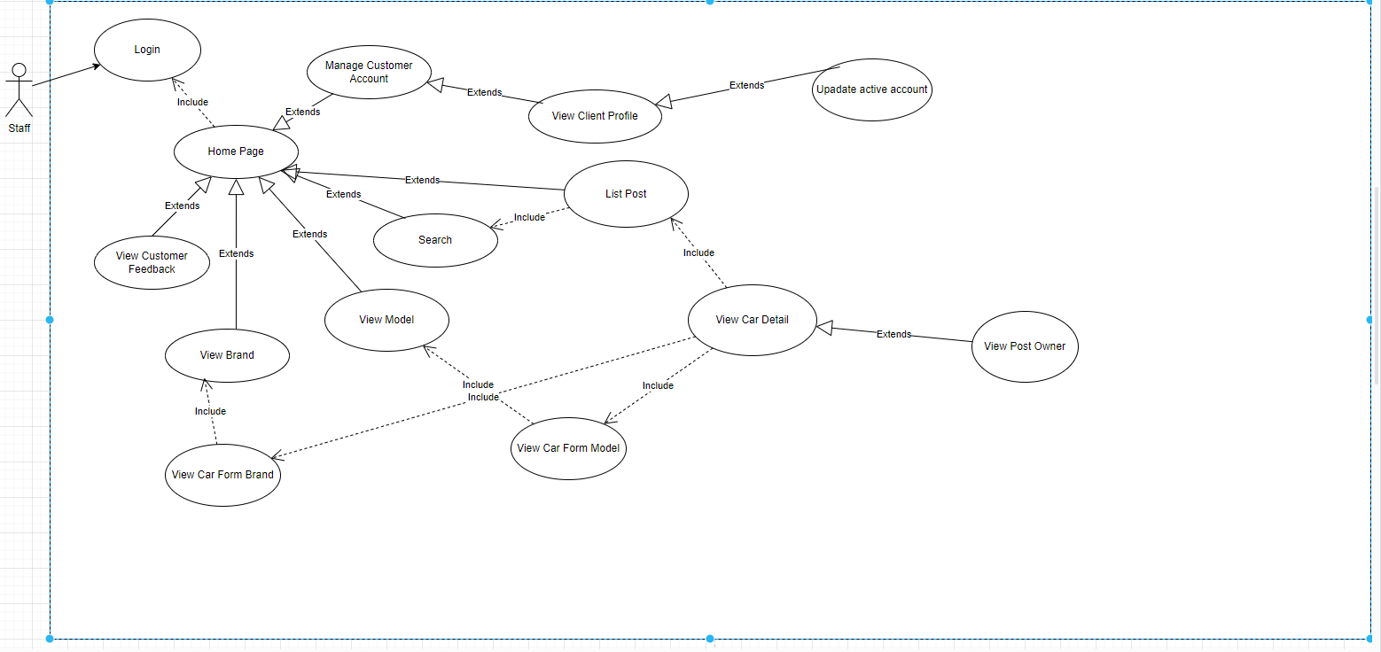

Context diagram here

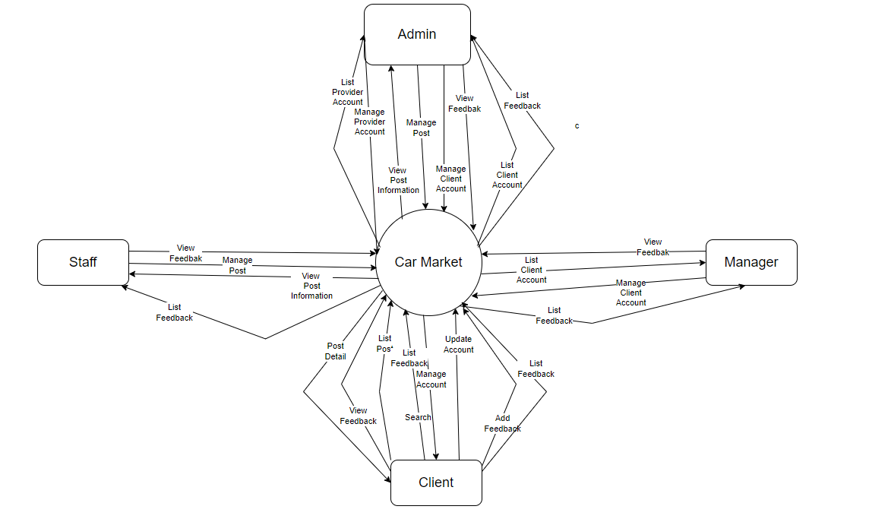

## System Feature Car Market

### Description

Features of the CarMarket system include: List Post, Manage Account, Home, Login, Profile, View Product, View Profile

### Stimulus/Response Sequences

List all event and FAP system must response with the even. Should write in table formate

### Home Screen Function

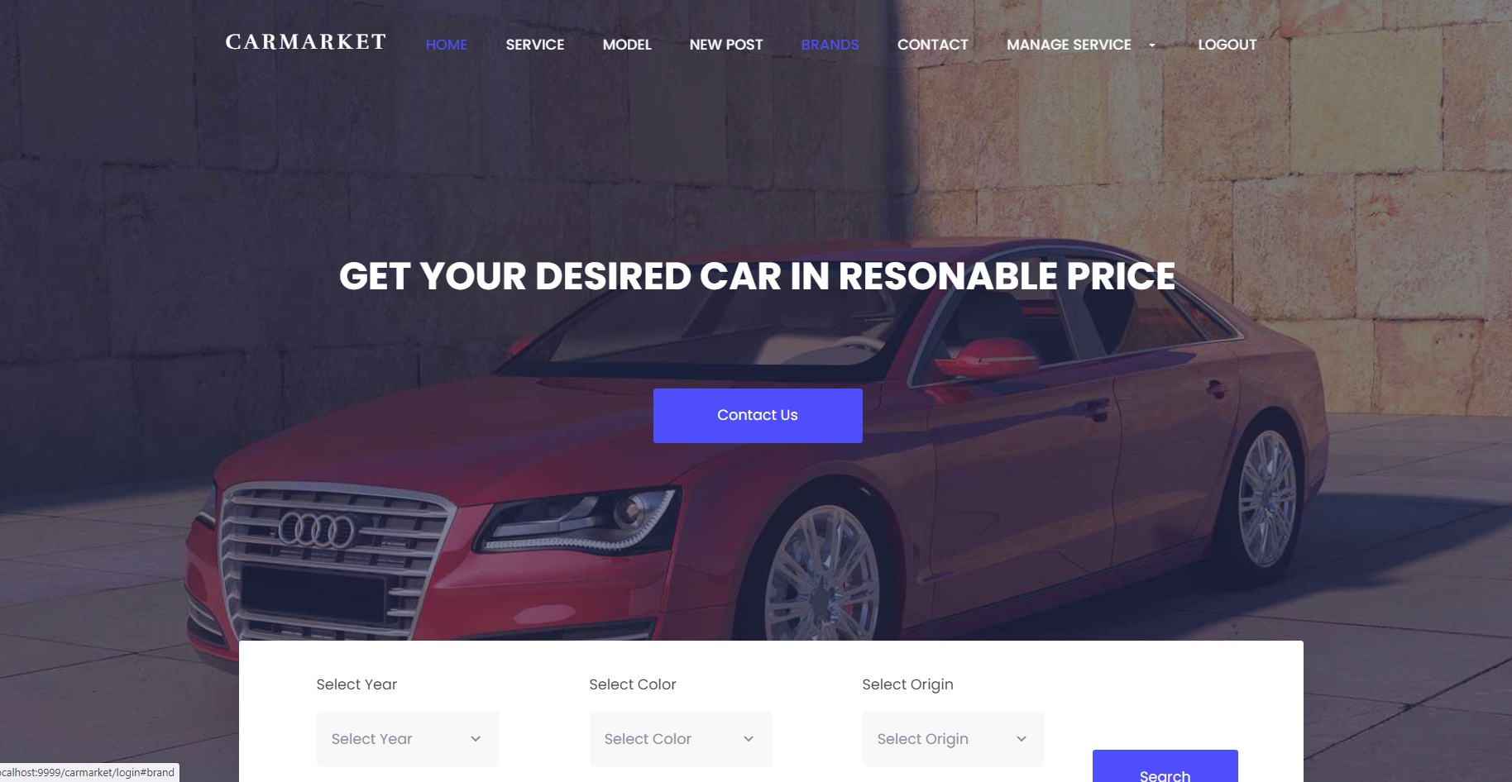

|  |  |  |  |
| --- | --- | --- | --- |
| UC ID and Name: | UC-6_Home page | | |
| Created By: | TuanND | Date Created: | 20/5/2024 |
| Primary Actor: | Client | Secondary Actors: | Manager, Admin, Staff |
| Trigger: | When user login into account | | |
| Description: | As user, I want to see a homepage to know what kind of this website | | |
| Preconditions: | Login or click to home page | | |
| Postconditions: | * Success: return to home page | | |
| Normal Flow: | 6.0 Home page  1. User accesses the Login screen  2. User login with account success and the system will switch to homepage  3.Also user can click to home page on the menu tab | | |
| Alternative Flows: |  | | |
| Exceptions: | ***6.0.E1 System not accept user information***  1. When user out time of session it will return to login page with announce | | |
| W | High , Must Have | | |
| Frequency of Use: | Always | | |
| Business Rules: | FR8 | | |
| Other Information: |  | | |
| Assumptions: |  | | |

#### b. Business Rules

Provide the business rules those are applied only to the use case

|  |  |  |
| --- | --- | --- |
| **ID** | **Business Rule** | **Business Rule Description** |
| FR8 | Home page must have login | User must login to account to go for homepage |

### Function Login

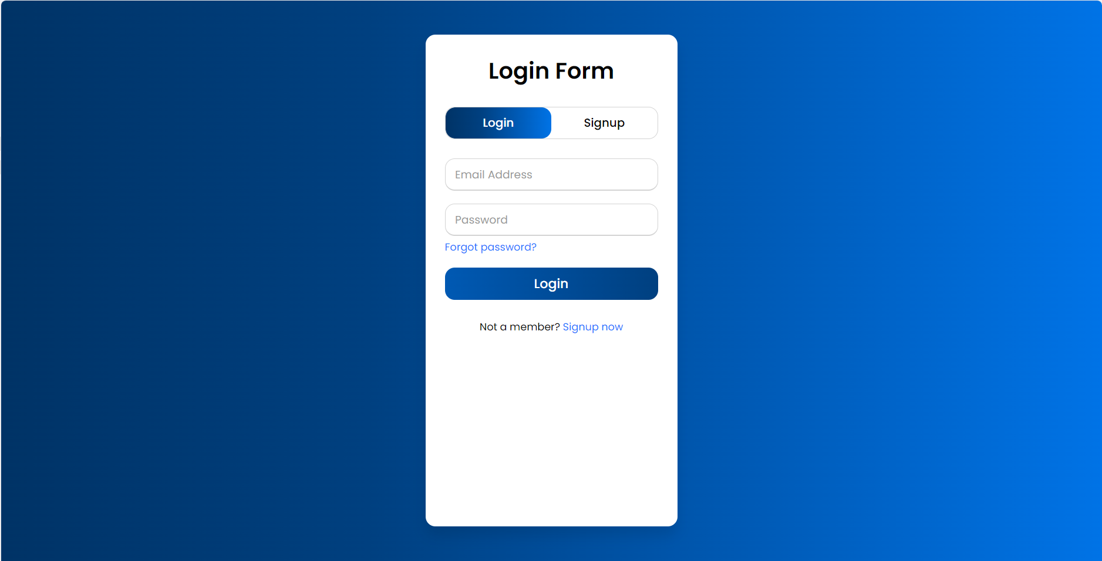

|  |  |  |  |
| --- | --- | --- | --- |
| UC ID and Name: | **UC-2_Login System** | | |
| Created By: | TuanND | Date Created: | 15/5/2024 |
| Primary Actor: | Client | Secondary Actors: |  |
| Trigger: | The user wants to log in to the Car website | | |
| Description: | As a user, I want to be able to log into the system so that I can use the system’s authenticated features and access my personalized account. | | |
| Preconditions: | The user account has been previously registered. | | |
| Postconditions: | * Success: return to the home page * Failure: The system reports an error corresponding to the error | | |
| Normal Flow | **2.0 Login System**  1. User accesses the User Login screen  2. User types in the login details or choo other login options  3.User enters email and password  4. User clicks the Login button  5. System validates the login details  6. System allows user to access  7. System accesses the Home Page (or the previous calling page if any) | | |
| Alternative Flows: |  | | |
| Exceptions: | ***2.0.E1 System can’t authenticate the user***  1. The Error Message screen is shown to the user  2. User cancels the logging in *=> UC stops, change to UC-1_View Home Page*  3. User clicks “Forgot Password?” link *=> change to UC-3_Reset Password*  4. User clicks “Register” link *=> change to UC-4_Register User Account* | | |
| Priority: | Must Have | | |
| Frequency of Use: | Always | | |
| Business Rules: | None | | |
| Assumptions: | The user's internet connection must be available. | | |

### Mange Profile

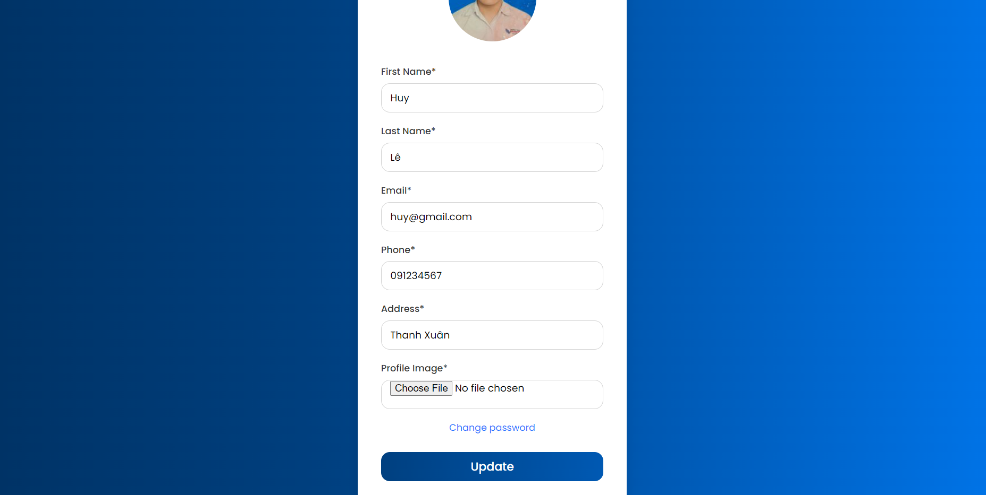

|  |  |  |  |
| --- | --- | --- | --- |
| UC ID and Name: | **UC-3_Manage Profile** | | |
| Created By: | TuanND | Date Created: | 15/5/2024 |
| Primary Actor: | Client | Secondary Actors: | Staff |
| Trigger: | Client can view and update their profile | | |
| Description: | As a client I want to update my profile for some situation | | |
| Preconditions: | The user account has been previously registered and not be ban. | | |
| Postconditions: | * Success: Return to view profile * Failure: The system will return view profile and warning “you need input .png folder” | | |
| Normal Flow | **3.0 Manage Profile**  1. Client login with their account  2. After login success, system will go to homepage  3.Enter mange Profile in service function  4. User can see their information profile | | |
|  |  | | |
| Exceptions: | ***System 3.0.E1 cannot authenticate users***  1. The Error Message screen is displayed to the user | | |
| Priority: | Must Have | | |
| Frequency of Use: | Sometime | | |
| Business Rules: | FR3, FR4 | | |
| Assumptions: |  | | |

#### b. Business Rules

|  |  |  |
| --- | --- | --- |
| **ID** | **Business Rule** | **Business Rule Description** |
| FR3 | Upload Image | Client must upload .png folder |
| FR4 | Invalid Blank | Client canot leave blank any frofilr infomation |

### Manage Customer Account

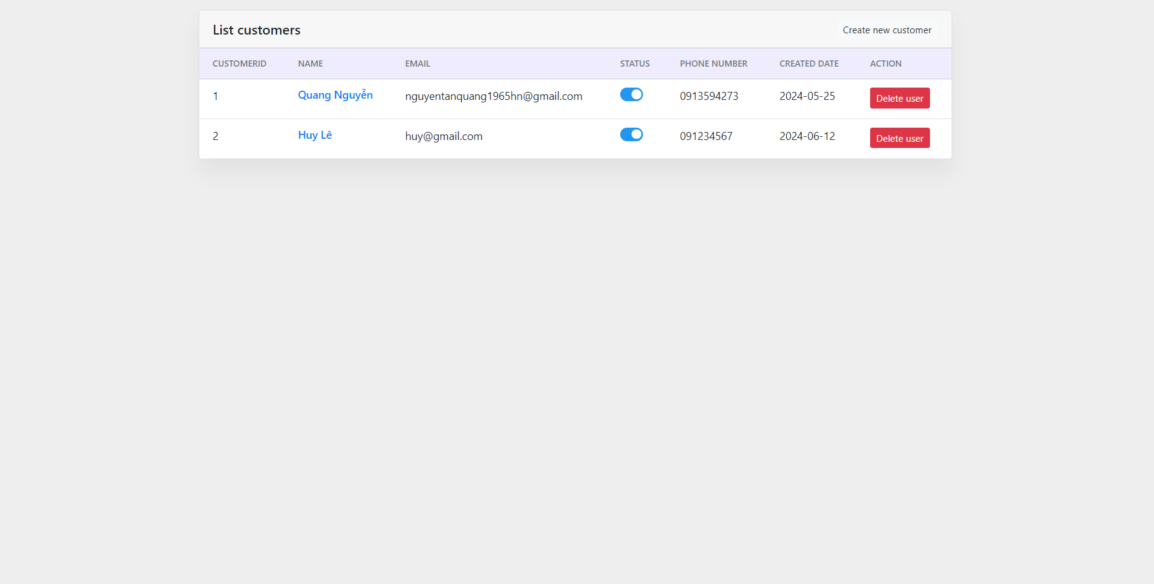

|  |  |  |  |  |
| --- | --- | --- | --- | --- |
| ID and Name: | | **Manage Customer Account** | | |
| Created By: | TuanND | Date Created: | 15/5/2024 |
| Primary Actor: | Admin | Secondary Actors: | Staff |
| Description: | As a provider, I want to the list of account to manage them | | |
| Trigger: | User request a function to list all the account from client and provider and show their role | | |
| Preconditions: | PRE-1. The account must be provider | | |
| Postconditions: | POST-2. The account mustn’t be banned | | |
| Normal Flow: | **14.0 Forgot password**   1. The user login with provider account 2. Go to service and click to manage account | | |
| Alternative Flows: | None | | |
| Exceptions: |  | | |
| Priority: | High | | |
| Business Rules: | FR15 | | |
| Other Information: | Expect high frequency of executing this use case within first 2 weeks after system is released. | | |

#### b. Business Rules

|  |  |  |
| --- | --- | --- |
| **ID** | **Business Rule** | **Business Rule Description** |
| FR15 | Role Account | All provider’s role can be list account but only few role have right to mange list account |

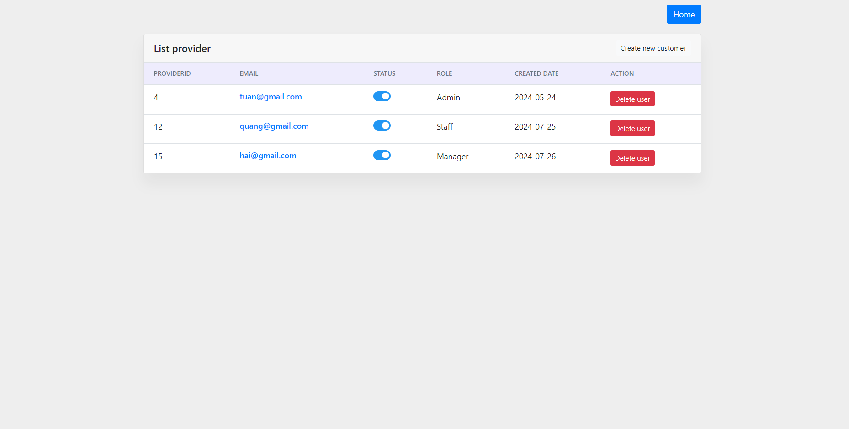

|  |  |  |  |  |
| --- | --- | --- | --- | --- |
| ID and Name: | | **Manage Provider Account** | | |
| Created By: | TuanND | Date Created: | 15/5/2024 |
| Primary Actor: | Admin | Secondary Actors: |  |
| Description: | As a provider, I want to the list of account to manage them | | |
| Trigger: | User request a function to list all the account from client and provider and show their role | | |
| Preconditions: | PRE-1. The account must be provider | | |
| Postconditions: | POST-2. The account mustn’t be banned | | |
| Normal Flow: | **14.0 Forgot password**   1. The user login with provider account 2. Go to service and click to manage account | | |
| Alternative Flows: | None | | |
| Exceptions: |  | | |
| Priority: | High | | |
| Business Rules: | FR15 | | |
| Other Information: | Expect high frequency of executing this use case within first 2 weeks after system is released. | | |

#### b. Business Rules

|  |  |  |
| --- | --- | --- |
| **ID** | **Business Rule** | **Business Rule Description** |
| FR15 | Role Account | All provider’s role can be list account but only few role have right to mange list account |

### Function Manage Post

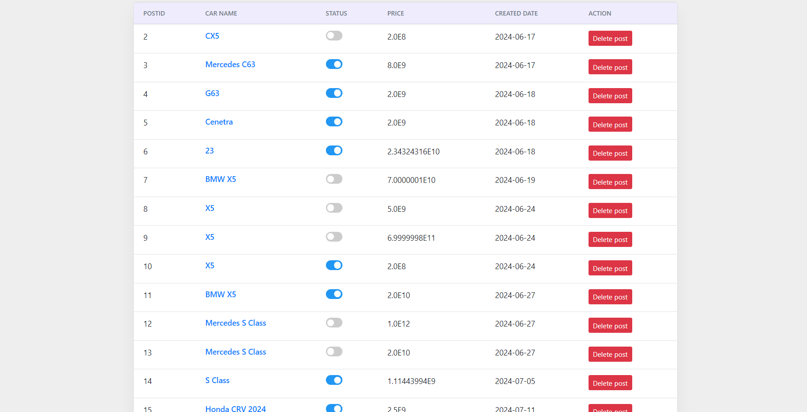

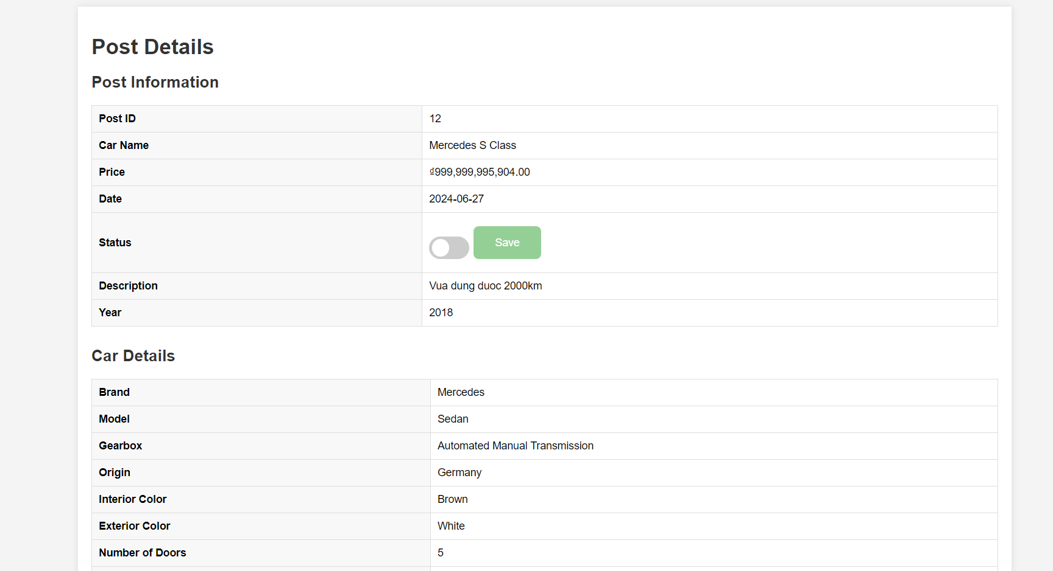

#### a. Functional Description

|  |  |  |  |
| --- | --- | --- | --- |
| ID and Name: | **UC-22 View Detail Post for Provider** | | |
| Created By: | TuanND | Date Created: | 17/6/2024 |
| Primary Actor: | Manager | Secondary Actors: | Admin, Staff |
| Description: | As a provider, I want to see user post detail | | |
| Trigger: | User want a function show all post information and client information who posting | | |
| Preconditions: | PRE-1. The account must be manager  PRE-2. The account mustn’t be banned | | |
| Postconditions: | None | | |
| Normal Flow: | 1. User login with manager account  2. Click in service in menu in homepage  3. Choose manage post  4. Click to the post that user want to approve  5. In this page have post information and client information  6. Switch this on status to approve | | |
| Alternative Flows: | None | | |
| Exceptions: | None | | |
| Priority: | High | | |
| Business Rules: | FR19 | | |
| Other Information: | Expect high frequency of executing this use case within first 2 weeks after system is released. | | |

#### b. Business Rules

|  |  |  |
| --- | --- | --- |
| **ID** | **Business Rule** | **Business Rule Description** |
| FR19 | Role | Only provider can use this view |

|  |  |  |  |
| --- | --- | --- | --- |
| ID and Name: | **UC-21 Post Approve** | | |
| Created By: | TuanND | Date Created: | 15/6/2024 |
| Primary Actor: | Manager | Secondary Actors: | None |
| Description: | As a manger, I want to approve the client’s post to accept client posting | | |
| Trigger: | User want a function update their posting table | | |
| Preconditions: | PRE-1. The account must be manager  PRE-2. The account mustn’t be banned | | |
| Postconditions: | None | | |
| Normal Flow: | 1. User login with manager account  2. Click in service in menu in homepage  3. Choose manage post  4. Click to the post that user want to approve  5. In this page have post information and client information  6. Switch this on status to approve | | |
| Alternative Flows: | None | | |
| Exceptions: | None | | |
| Priority: | High | | |
| Business Rules: | FR19 | | |
| Other Information: | Expect high frequency of executing this use case within first 2 weeks after system is released. | | |

#### b. Business Rules

|  |  |  |
| --- | --- | --- |
| **ID** | **Business Rule** | **Business Rule Description** |
| FR18 | Update | If any information you not update, client must also type this information again |
|  |  |  |

### Function View My Contract

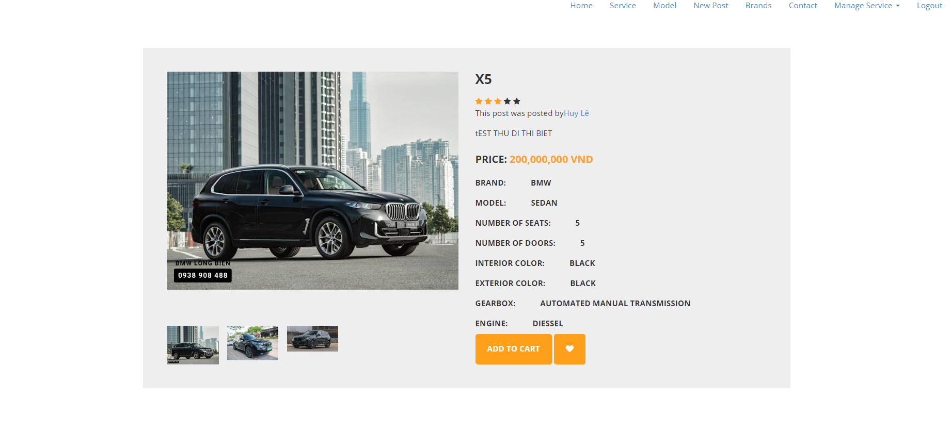

#### a. Functional Description

|  |  |  |  |
| --- | --- | --- | --- |
| UC ID and Name: | **UC-9_View Detail System** | | |
| Created By: | TuanND | Date Created: | 15/5/2024 |
| Primary Actor: | Client | Secondary Actors: | Manager, Admin, Staff |
| Trigger: | When user find the product they need to see detail information about the car | | |
| Description: | As a user, I want see detail information about the post to know about the car | | |
| Preconditions: | The user login or search the post | | |
| Postconditions: | * Success: go to detail post page * Failure: Time out session and return to login page | | |
| Normal Flow | **2.0 View Detail System**  1. User accesses the Login screen  2. User can view the list of post in search, latest post, All post, post by brand, post by model  3.Click into post name that they want to see | | |
| Alternative Flows: |  | | |
| Exceptions: | ***9.0.E1 System can’t authenticate the user***  1. Go back to login page and announce | | |
| Priority: | Must Have | | |
| Frequency of Use: | Always | | |
| Business Rules: | FR10, FR11 | | |
| Assumptions: | The user's internet connection must be available. | | |

#### b. Business Rules

|  |  |  |
| --- | --- | --- |
| **ID** | **Business Rule** | **Business Rule Description** |
| FR10 | Image | The detail post when user go view must have at least 2 image |
| FR11 | Owner post | * The detail post must also have owner’s name to check the verification of owner |

### Update active account

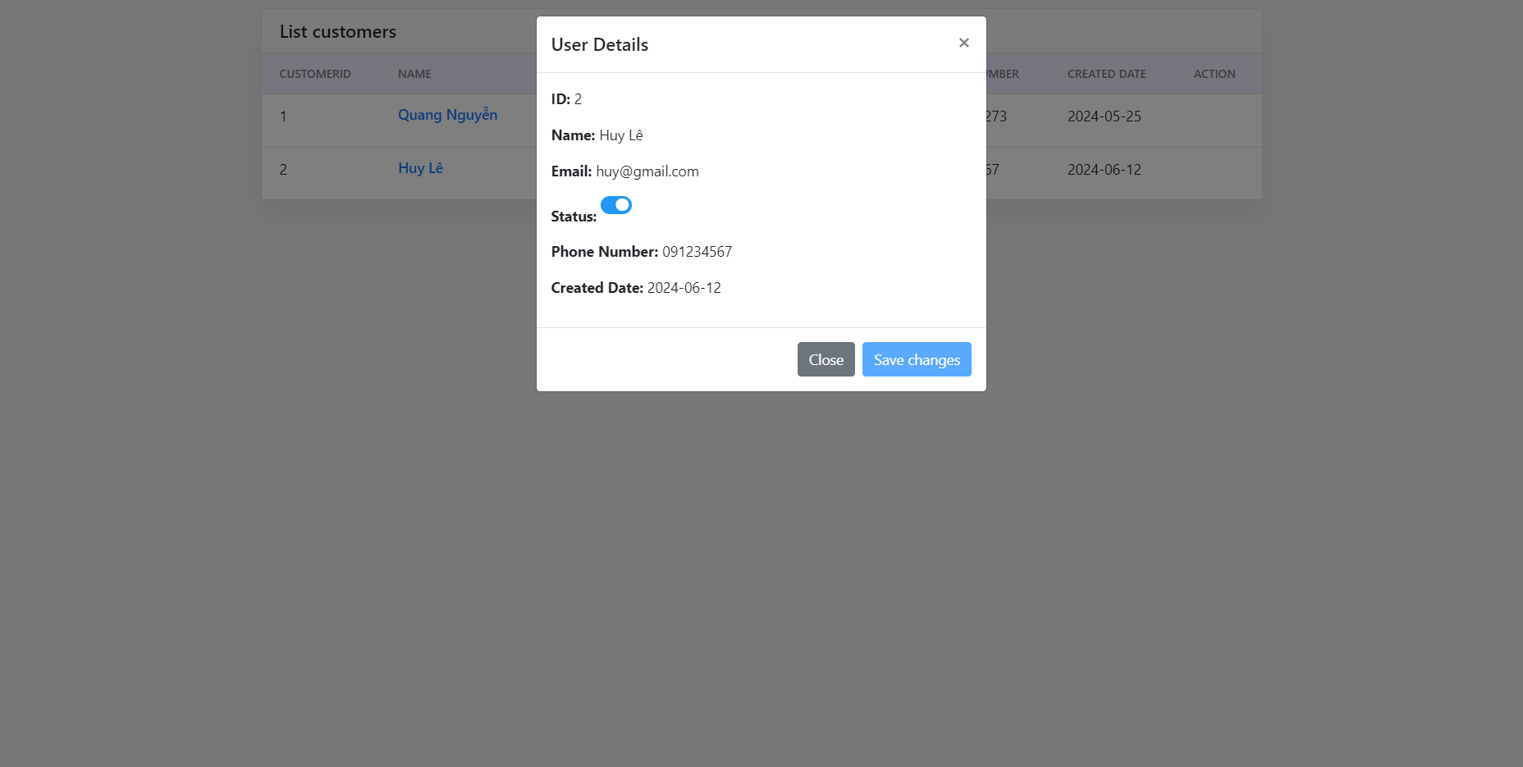

|  |  |  |  |
| --- | --- | --- | --- |
| ID and Name: | **Update active account** | | |
| Created By: | TuanND | Date Created: | 1/6/2024 |
| Primary Actor: | Admin | Secondary Actors: | None |
| Description: | As a admin, I want to create account so that I can set role for that account whatever I want | | |
| Trigger: | User want a function help them to create update or delete other account | | |
| Preconditions: | PRE-1. The account must be admin | | |
| Postconditions: | POST-2. The account mustn’t be banned | | |
| Normal Flow: | 1. The user login with admin account   1. Go to service and click to manage account 2. Click to account they want to update 3. Switch the status so that you want to update | | |
| Alternative Flows: | None | | |
| Exceptions: |  | | |
| Priority: | High | | |
| Business Rules: | None | | |
| Other Information: | Expect high frequency of executing this use case within first 2 weeks after system is released. | | |

### View Model & Insert Model

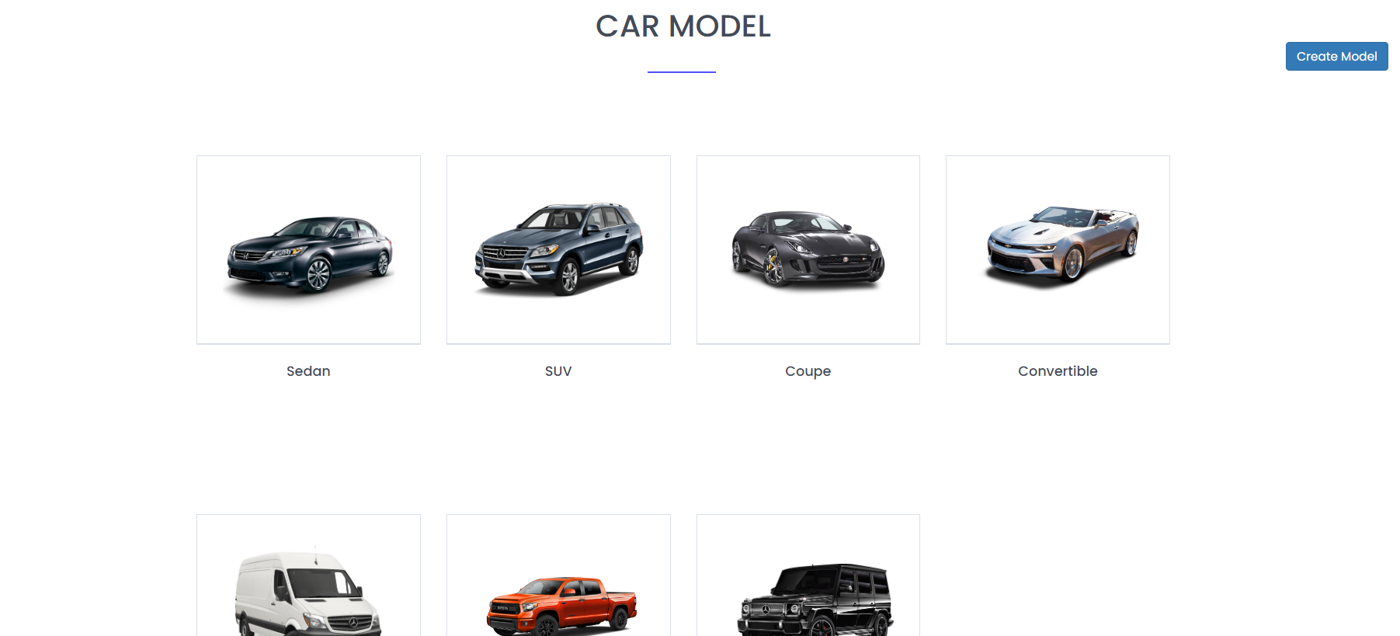

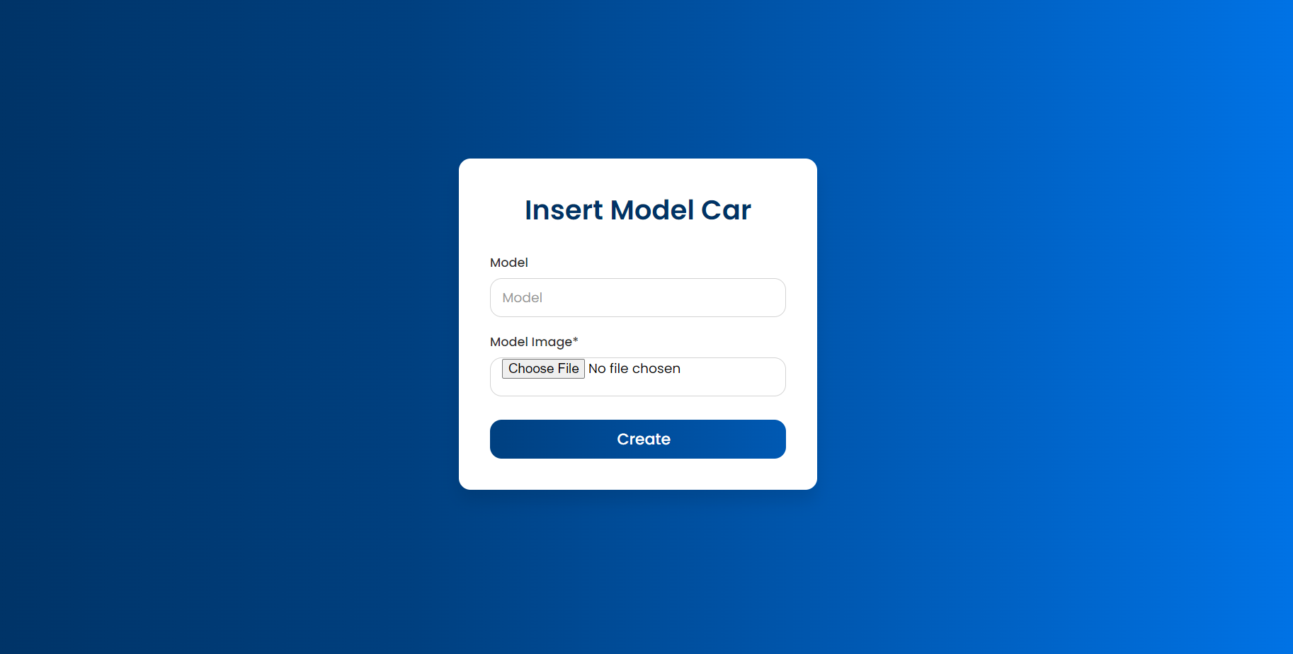

#### a. Functional Description

|  |  |  |  |
| --- | --- | --- | --- |
| ID and Name: | **UC-18 Insert Model** | | |
| Created By: | TuanND | Date Created: | 10/6/2024 |
| Primary Actor: | Admin | Secondary Actors: | None |
| Description: | As a admin, I want to insert model to update new model for their website | | |
| Trigger: | User want a function help them to create model | | |
| Preconditions: | PRE-1. The account must be admin | | |
| Postconditions: | POST-2. The account mustn’t be banned | | |
| Normal Flow: | 1. The user login with admin account  2. Scroll down to model on home page and click to see more  3. In this page click on insert model on the top  4. Enter name and image of form | | |
| Alternative Flows: | None | | |
| Exceptions: | None | | |
| Priority: | High | | |
| Business Rules: | FR16 | | |
| Other Information: | Expect high frequency of executing this use case within first 2 weeks after system is released. | | |

#### b. Business Rules

|  |  |  |
| --- | --- | --- |
| **ID** | **Business Rule** | **Business Rule Description** |
| FR16 | Insert Image | Admin must be insert image .png |
|  |  |  |

### View Brand & Insert Brand

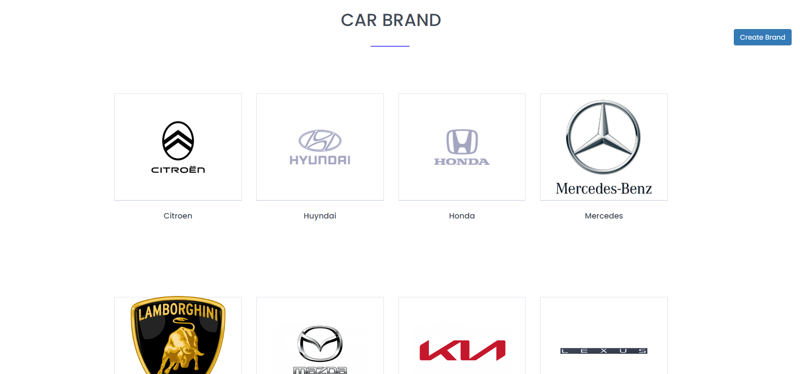

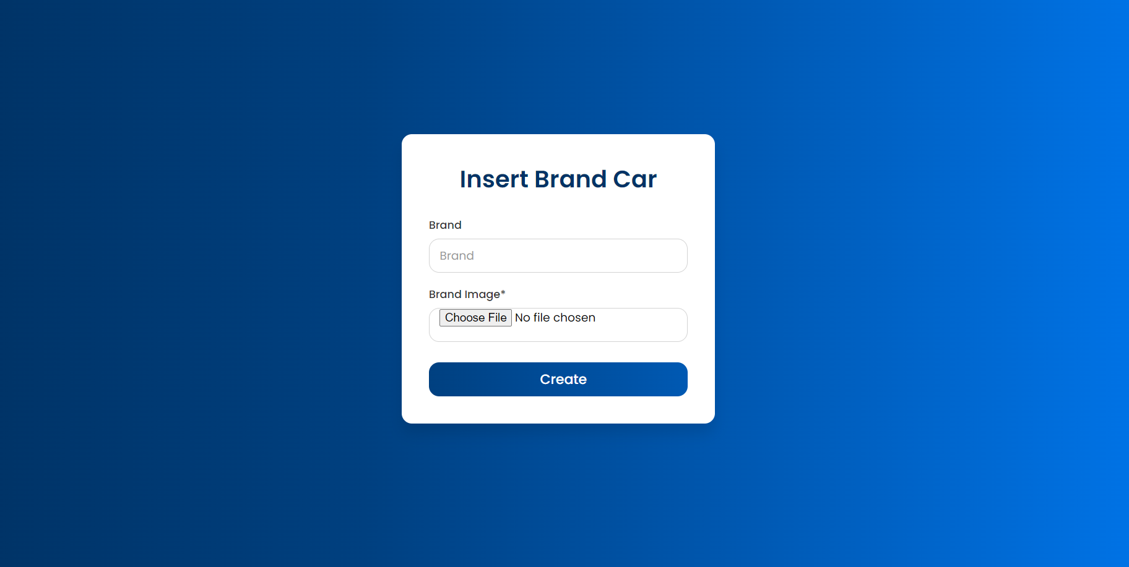

#### a. Functional Description

|  |  |  |  |
| --- | --- | --- | --- |
| ID and Name: | **UC-19 Insert Brand** | | |
| Created By: | TuanND | Date Created: | 12/6/2024 |
| Primary Actor: | Admin | Secondary Actors: | None |
| Description: | As a admin, I want to insert brand to update new brand for their website | | |
| Trigger: | User want a function help them to create brand | | |
| Preconditions: | PRE-1. The account must be admin  PRE-2. The account mustn’t be banned | | |
| Postconditions: | None | | |
| Normal Flow: | 1. The user login with admin account  2. Scroll down to model on home page and click to see more  3. In this page click on insert brand on the top  4. Enter name and image of form | | |
| Alternative Flows: | None | | |
| Exceptions: | None | | |
| Priority: | High | | |
| Business Rules: | FR17 | | |
| Other Information: | Expect high frequency of executing this use case within first 2 weeks after system is released. | | |

#### b. Business Rules

|  |  |  |
| --- | --- | --- |
| **ID** | **Business Rule** | **Business Rule Description** |
| FR17 | Insert Image | Admin must be insert image .png |
|  |  |  |

### Search

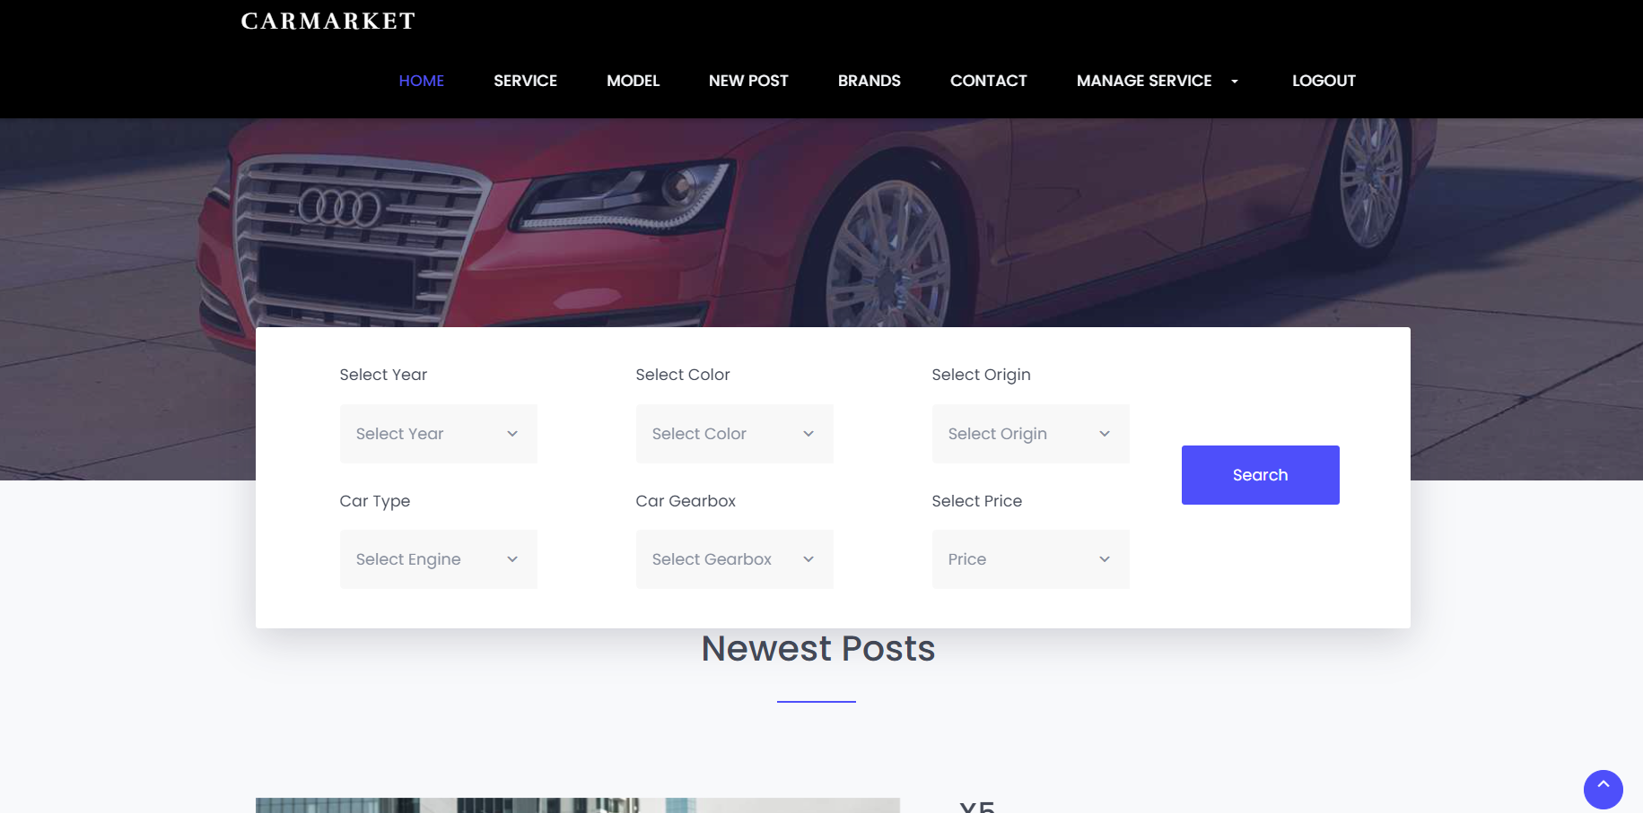

*a. Functional Description*

|  |  |  |  |
| --- | --- | --- | --- |
| UC ID and Name: | **UC-4_Search System** | | |
| Created By: | TuanND | Date Created: | 15/5/2024 |
| Primary Actor: | Client | Secondary Actors: | Manager, Admin, Staff |
| Trigger: | The user want search for some post or product | | |
| Description: | As a user, I want to search the product(post) by gearbox, origin, brand model … | | |
| Preconditions: | The user has go to homepage | | |
| Postconditions: | * Success: go to search result * Failure: can not find result | | |
| Normal Flow | **4.0 Search System**  1. User accesses the User Login screen  2. User types in the login details  3. After go into homepage user will see the condition car user want to see  4. chosing the condition car user want to see after that click search | | |
| Alternative Flows: |  | | |
| Exceptions: | ***4.0.E1 System can’t authenticate the user***  1. When user click search without choosing any condition | | |
| Priority: | Must Have | | |
| Frequency of Use: | Always | | |
| Business Rules: | FR5,FR6 | | |
| Assumptions: | The user's internet connection must be available. | | |

#### b. Business Rules

|  |  |  |
| --- | --- | --- |
| **ID** | **Business Rule** | **Business Rule Description** |
| FR5 | Seach directly | The search system must have search correctly the post have same condition with user choosing |
| FR6 | Cant find post | If the system cant find post with user’s condition, the system need to announce “there is no result” |

# Data Requirements

## Logical Data Model

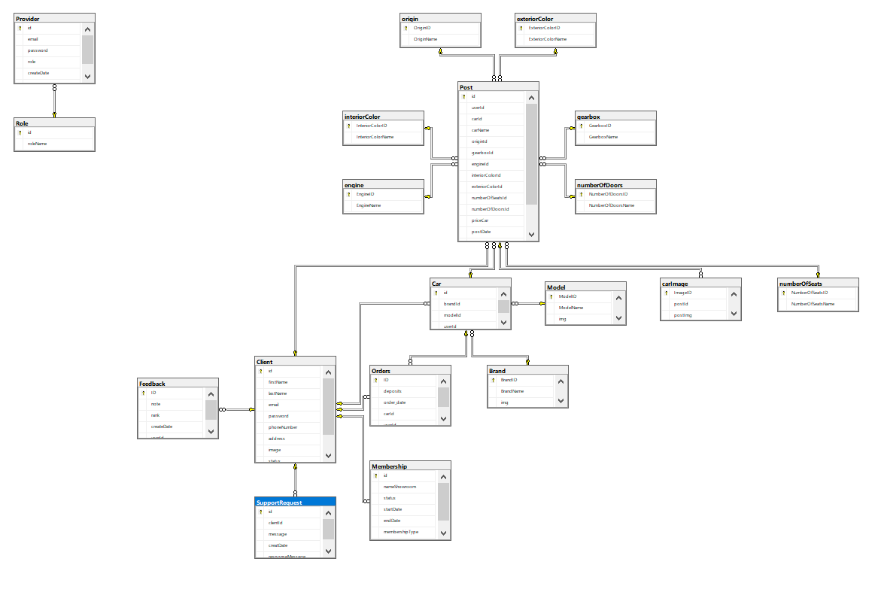

## Data Dictionary

|  |  |  |
| --- | --- | --- |
| No | Table | Description |
| 1 | Client | Store information for user who buy or sale product on profile id id INT PRIMARY KEY IDENTITY(1,1),  firstName NVARCHAR(50) NOT NULL,  lastName NVARCHAR(50) NOT NULL,  email NVARCHAR(50) NOT NULL,  password NVARCHAR(50) NOT NULL,  phoneNumber NVARCHAR(10) NOT NULL,  address NVARCHAR(100) NOT NULL,  image NVARCHAR(100),  status BIT NOT NULL,  createDate DATE NOT NULL, |
| 2 | Provider | Store user information of admin, manager and staff  id INT PRIMARY KEY IDENTITY(1,1),  email NVARCHAR(50) NOT NULL,  password NVARCHAR(50) NOT NULL,  role int NOT NULL,  createDate DATE NOT NULL,  status BIT NOT NULL,  CONSTRAINT FK_Account_Role FOREIGN KEY (role) REFERENCES Role(id) |
| 3 | Role | Store id and name of the role  id int PRIMARY KEY IDENTITY(1,1),  roleName NVARCHAR(50) NOT NULL |
| 4 | Feedback | Store user feedback about the website  ID INT PRIMARY KEY IDENTITY(1,1),  note NVARCHAR(50) NOT NULL,  rank NVARCHAR(50) NOT NULL,  createDate DATE NOT NULL,  userId INT NOT NULL,  CONSTRAINT FK_Feedback_User FOREIGN KEY (userId) REFERENCES Client(id) |
| 5 | Membership | Store information about user who become membership and earn special offer  id INT PRIMARY KEY IDENTITY(1,1),  nameShowroom NVARCHAR(50) NOT NULL,  status BIT NOT NULL,  startDate DATE NOT NULL,  endDate DATE NOT NULL,  membershipType INT NOT NULL,  userId INT NOT NULL,  CONSTRAINT FK_Membership_User FOREIGN KEY (userId) REFERENCES [Client](id) |
| 6 | Orders | Store orders from user who paid to post single news or paid monthly to become memberships, orders of the person who buy cars  ID INT PRIMARY KEY IDENTITY(1,1),  deposits FLOAT NOT NULL,  order_date DATE NOT NULL,  carId INT NOT NULL,  userId INT NOT NULL,  CONSTRAINT FK_Orders_Car FOREIGN KEY (carId) REFERENCES Car(id),  CONSTRAINT FK_Orders_User FOREIGN KEY (userId) REFERENCES [Client](id) |
| 7 | Car | Store informations about cars that show on the car list  id INT PRIMARY KEY IDENTITY(1,1),  brandId int NOT NULL,  modelId int NOT NULL,  userId INT NOT NULL,  CONSTRAINT FK_Car_Brand FOREIGN KEY (brandId) REFERENCES Brand(BrandID),  CONSTRAINT FK_Car_Model FOREIGN KEY (modelId) REFERENCES Model(ModelID),  CONSTRAINT FK_Car_User FOREIGN KEY (userId) REFERENCES [Client](id) |
| 8 | Model | Store car model to show on car list  ModelID int PRIMARY KEY IDENTITY(1,1),  ModelName NVARCHAR(50) NOT NULL,  img VARCHAR(225) |
| 9 | Brand | Store car brand to show car list  BrandID int PRIMARY KEY IDENTITY(1,1),  BrandName NVARCHAR(50) NOT NULL,  img VARCHAR(225) |
| 10 | Post | Store information about post from user  id INT PRIMARY KEY IDENTITY(1,1),  userId INT NOT NULL,  carId INT NOT NULL,  carName NVARCHAR(MAX) NOT NULL,  year DATE NOT NULL,  originId INT NOT NULL,  gearboxId INT NOT NULL,  engineId INT NOT NULL,  interiorColorId INT NOT NULL,  exteriorColorId INT NOT NULL,  numberOfSeatsId INT NOT NULL,  numberOfDoorsId INT NOT NULL,  priceCar FLOAT NOT NULL,  postDate DATE NOT NULL,  status BIT NOT NULL,  descriptions NVARCHAR(1000),  CONSTRAINT FK_Post_User FOREIGN KEY (userId) REFERENCES [Client](id),  CONSTRAINT FK_Post_Car FOREIGN KEY (carId) REFERENCES [Car](id),  CONSTRAINT FK_Post_Origin FOREIGN KEY (originId) REFERENCES [origin](OriginID),  CONSTRAINT FK_Post_Gearbox FOREIGN KEY (gearboxId) REFERENCES [gearbox](GearboxID),  CONSTRAINT FK_Post_Engine FOREIGN KEY (engineId) REFERENCES [engine](EngineID),  CONSTRAINT FK_Post_InteriorColor FOREIGN KEY (interiorColorId) REFERENCES [interiorColor](InteriorColorID),  CONSTRAINT FK_Post_ExteriorColor FOREIGN KEY (exteriorColorId) REFERENCES [exteriorColor](ExteriorColorID),  CONSTRAINT FK_Post_NumberOfSeats FOREIGN KEY (numberOfSeatsId) REFERENCES [numberOfSeats](NumberOfSeatsID),  CONSTRAINT FK_Post_NumberOfDoors FOREIGN KEY (numberOfDoorsId) REFERENCES [numberOfDoors](NumberOfDoorsID) |
| 11 | carImage | Store image of client car  ImageID int PRIMARY KEY IDENTITY(1,1),  postId INT NOT NULL,  postImg VARCHAR(225)  CONSTRAINT FK_Post_carImage FOREIGN KEY (postId) REFERENCES [Post](id) |
| 12 | Gearbox | Store Car’s gearbox  GearboxID int PRIMARY KEY IDENTITY(1,1),  GearboxName NVARCHAR(50) NOT NULL |
| 13 | numberOfDoor | Store number of car’s door  NumberOfDoorsID int PRIMARY KEY IDENTITY(1,1),  NumberOfDoorsName NVARCHAR(50) NOT NULL |
| 14 | exteriorColor | Store car’s exterior color  ExteriorColorID int PRIMARY KEY IDENTITY(1,1),  ExteriorColorName NVARCHAR(50) NOT NULL |
| 15 | origin | Store Car’s origin  OriginID int PRIMARY KEY IDENTITY(1,1),  OriginName NVARCHAR(50) NOT NULL |
| 16 | interiorColor | Store car’s interior color  InteriorColorID int PRIMARY KEY IDENTITY(1,1),  InteriorColorName NVARCHAR(50) NOT NULL |
| 17 | engine | Store Car’s engine  EngineID int PRIMARY KEY IDENTITY(1,1),  EngineName NVARCHAR(50) NOT NULL |
| 18 | NumberOfSeats | Store number of car’s seat  NumberOfSeatsID int PRIMARY KEY IDENTITY(1,1),  NumberOfSeatsName NVARCHAR(50) NOT NULL |
| 19 | SupportRequest | Store information about support that user wrote down for manager or admin  id INT PRIMARY KEY IDENTITY(1,1),  clientId INT NOT NULL,  message NVARCHAR(MAX) NOT NULL,  creatDate DATE NOT NULL,  responseMessage NVARCHAR(MAX) NOT NULL,  CONSTRAINT FK_SupportRequest_User FOREIGN KEY (clientId) REFERENCES [Client](id) |

# External Interface Requirements

*<This section provides information to ensure that the system will communicate properly with users and with external hardware or software elements.>*

## User Interfaces

*<Describe the logical characteristics of each interface between the software product and the users. This may include sample screen images, any GUI standards or product family style guides that are to be followed, screen layout constraints, standard buttons and functions (e.g., help) that will appear on every screen, keyboard shortcuts, error message display standards, and so on. Define the software components for which a user interface is needed. Details of the user interface design should be documented in a separate user interface specification.>*

## Software Interfaces

## Hardware Interfaces

*<Describe the characteristics of each interface between the software and hardware (if any) components of the system. This description might include the supported device types, the data and control interactions between the software and the hardware, and the communication protocols to be used. List the inputs and outputs, their formats, their valid values or ranges, and any timing issues developers need to be aware of. If this information is extensive, consider creating a separate interface specification document.>*

## Communications Interfaces

*<State the requirements for any communication functions the product will use, including e-mail, Web browser, network protocols, and electronic forms. Define any pertinent message formatting. Specify communication security or encryption issues, data transfer rates, handshaking, and synchronization mechanisms. State any constraints around these interfaces, such as whether e-mail attachments are acceptable or not.>*

# Quality Attributes

## Usability

*<Specify any requirements regarding characteristics that will make the software appear to be “user-friendly.” Usability encompasses ease of use, ease of learning; memorability; error avoidance, handling, and recovery; efficiency of interactions; accessibility; and ergonomics. Sometimes these can conflict with each other, as with ease of use over ease of learning. Indicate any user interface design standards or guidelines to which the application must conform.>*

## Performance

*<State specific performance requirements for various system operations. If different functional requirements or features have different performance requirements, it's appropriate to specify those performance goals right with the corresponding functional requirements, rather than collecting them in this section.>*

## Security

*<Specify any requirements regarding security or privacy issues that restrict access to or use of the product. These could refer to physical, data, or software security. Security requirements often originate in business rules, so identify any security or privacy policies or regulations to which the product must conform. If these are documented in a business rules repository, just refer to them.>*

## Safety

*<Specify requirements that are concerned with possible loss, damage, or harm that could result from use of the product. Define any safeguards or actions that must be taken, as well as potentially dangerous actions that must be prevented. Identify any safety certifications, policies, or regulations to which the product must conform.>*

## [Others as relevant]

*<Create a separate section in the SRS for each additional product quality attribute to describe characteristics that will be important to either customers or developers. Possibilities include availability, efficiency, installability, integrity, interoperability, modifiability, portability, reliability, reusability, robustness, scalability, and verifiability. Write these to be specific, quantitative, and verifiable. Clarify the relative priorities for various attributes, such as security over performance.>*

# Internationalization and Localization Requirements

*<Internationalization and localization requirements ensure that the product will be suitable for use in nations, cultures, and geographic locations other than those in which it was created. Such requirements might address differences in: currency; formatting of dates, numbers, addresses, and telephone numbers; language, including national spelling conventions within the same language (such as American versus British English), symbols used, and character sets; given name and family name order; time zones; international regulations and laws; cultural and political issues; paper sizes used; weights and measures; electrical voltages and plug shapes; and many others.>*

# Other Requirements

*<Examples are: legal, regulatory or financial compliance, and standards requirements; requirements for product installation, configuration, startup, and shutdown; and logging, monitoring and audit trail requirements. Instead of just combining these all under "Other," add any new sections to the template that are pertinent to your project. Omit this section if all your requirements are accommodated in other sections. >*

**Appendix A: Glossary**

*<Define any specialized terms that a reader needs to know to understand the SRS, including acronyms and abbreviations. Spell out each acronym and provide its definition. Consider building a reusable enterprise-level glossary that spans multiple projects and incorporating by reference any terms that pertain to this project.>*

**Appendix B: Analysis Models**

*<This optional section includes or points to pertinent analysis models such as data flow diagrams, feature trees, state-transition diagrams, or entity-relationship diagrams. You might prefer to insert certain models into the relevant sections of the specification instead of collecting them at the end.>*